**Blood Bank Management System**

**A PROJECT REPORT**

**Submitted to the faculty of Computer Science of**

**SARASWATI SISHU VIDYA MANDIR, NEELAKANTHA NAGAR**

**BERHAMPUR, ODISHA 760002**

**In partial fulfilment of the requirements**

**for the award of the degree**

**Bachelor in Science**

**With Specialization**

**Computer Science**

**By**

**Rajat Kumar Behera (SV2121559)**

**Under the guidance of**

**Shri. Santosh Kumar Raul (HOD of Computer Science)**

**Smt. Rashmi Rani Panda**

**Shri. Kailash Chandra Nayak**



**Department of Computer Science  
 SARASWATI DEGREE VIDYA MANDIR, NEELAKANTHA NAGAR**

**(Affiliated to Berhampur University)**

**Berhampur,Ganjam**

**Odisha – 760002**

**DECLERATION**

I declared that the project work entitled “Blood Bank Management System” is developed by Rajat Kumar Behera under the guidance of my faculty Mr.Santosh Kumar Raul, HOD of the Computer Science Department Saraswati Neelakantha Nagar, Berhampur and Odisha. This project is submitted for partial fulfilment of requirement as per the curriculum of B.Sc. final year. This original work is done by me and no part of it has been ever submitted for any degree of diploma of any institutions previously under my knowledge.

Rajat Kumar Behera

Roll no: SV2121559

Reg. no: 21998/2020

+3 Final Year (2020-2023)

**ACKNOWLEDGEMENT**

This is a golden opportunity for me to work on the project “Blood Bank Management System” with the permission of MRs. Santosh Kumar Raul, HOD and Department of Computer Science.

I am deeply indebted to faculty who is also my guide in this for selecting such a nice topic to work with. His constant support guidance and valuable suggestion helped me to carry out my project work smoothly. I am also thankful to all my teachers for their kind suggestions during the development of the evaluation of this project.

With Best regards

Rajat Kumar Behera

(SV2121559)



SARASWATI DEGREE VIDYAMANDIR

BERHAMPUR

**CERTIFICATE**

This is to certifying that “Blood Bank Management System” embodies the original work done by, “Rajat Kumar Behera” during 2022-23 project submission as a partial fulfilment of the requirement for the projects for the completion of **Bachelor of Science (B.Sc.) in Computer Science at Saraswati Degree Vidya Mandir , Berhampur.**

Signature of external Signature of H.O.D

(Dept. of CSC)

**CONTENT**

**Abstract ---------------------------------------------------------------------------------------- 07**

***Chapter 1: Introduction***

1.0 Introduction ----------------------------------------------------------------------------- 08

1.1 Background ------------------------------------------------------------------------------ 08

1.2 Problem Statement -------------------------------------------------------------------- 09

1.3 General Objective ---------------------------------------------------------------------- 09

1.4 Specific Objective ---------------------------------------------------------------------- 09

1.5 Scope of the study --------------------------------------------------------------------- 09  
 1.5.1 User Registration ----------------------------------------------------------- 09

1.5.2 View and edit information ----------------------------------------------- 09

1.5.3 Blood request research -------------------------------------------------- 09

1.5.4 Recording donation records --------------------------------------------- 10

1.6 Significance of the System ----------------------------------------------------------- 10

***Chapter 2: Requirement Analysis***

2.1 Software Requirement --------------------------------------------------------------- 11

2.2 Hardware Requirements ------------------------------------------------------------ 11

2.3 Designing or Modeling the System ------------------------------------------------ 11

***Chapter 3: Methodology***

3.1 Introduction ----------------------------------------------------------------------------- 14

3.2 Process model -------------------------------------------------------------------------- 14

3.2.1 Verification phase --------------------------------------------------------- 15

3.2.2 Coding phase --------------------------------------------------------------- 15

3.2.3 Validation phase ----------------------------------------------------------- 15

3.2.4 Requirement ---------------------------------------------------------------- 16

3.2.5 Entity relationship diagram ---------------------------------------------- 17

3.2.6 Use case Diagram ---------------------------------------------------------- 18

3.2.7 Data flow diagram --------------------------------------------------------- 18

***Chapter 4: Project manual*** --------------------------------------------------------------- 19

***Chapter 5: Source code of project*** ------------------------------------------------------- 26

***Chapter 6: Form layout*** -------------------------------------------------------------------- 96

***Chapter 7: Testing***

7.0 Testing -------------------------------------------------------------------------------------- 99

7.1 Levels of testing -------------------------------------------------------------------------- 99

7.2 Types of testing ------------------------------------------------------------------------ 100

***Chapter 8: Software Maintenance***

8.0 Software Maintenance --------------------------------------------------------------- 101

8.1 Categories of Software maintenance --------------------------------------------- 101

8.2 Need for maintenance ---------------------------------------------------------------- 102

***Chapter 9: Conclusion***

Conclusion ------------------------------------------------------------------------------------ 103

Future Plan ----------------------------------------------------------------------------------- 103

Bibliography ---------------------------------------------------------------------------------- 104

**ABSTRACT**:

Help Line is a voluntary and non-governmental organization. It maintains online library of blood donors in India. Sometimes Doctors and Blood bank project have to face the difficulty in finding the blood group Donors at right time. Help Line has attempted to provide the answer by taking upon itself the task of collecting Blood bank project nationwide for the cause and care of people in need. At any point of time the people who are in need can reach the donors through our search facility. By mobilizing people and organization who desire to make a difference in the lives of people in need. On the basis of humanity, everyone is welcome to register as a blood donor. Blood Bank Management System (BBMS) is a browser-based system that is designed to store, process, retrieve and analyse information concerned with the administrative and inventory management within a blood bank. This project aims at maintaining all the information pertaining to blood donors, different blood groups available in each blood bank and help them manage in a better way. Aim is to provide transparency in this field, make the process of obtaining blood from a blood bank hassle free and corruption free and make the system of blood bank management effective.

**CHAPTER: 1**

1. **Introduction:**

Blood is universally recognized as the most precious element that sustains life. It saves innumerable lives across the world in a variety of conditions. A blood bank is a place designed especially for the storage of blood and blood products. The term "blood bank" typically refers to a division of a hospital laboratory where the storage of blood product occurs and where proper testing is performed to reduce the risk of transfusion related events. Large coolers hold these products at a constant temperature and they are available at a moment's notice. The blood donor information system offers functionalities to quick access to register the donor, and collected donor details from various parts of the Provinces. It enables monitoring of the results and performance of the blood donation activity such that relevant and measurable objectives of the organization can be checked. In my system I’m providing the efficient search who needs the blood in their own city, name, and blood groups as fast as possible. Blood Bank or the Hospital accept the donated blood, only if donor satisfy all of the following conditions.

• If the donors are between age group of 18-60 years.

• If the donor’s weight is 45 kg’s or more.

• If the donor’s hemoglobin is 12.5 gm% minimum.

• If the donor’s last blood donation was 6 or more months earlier and etc.

**1.1.BACKGROUND:**

The Blood Donor information system is fully computerized system it makes easy to manage the system by the administrator. And the beginning of this project is research. I mean researching new things and identify the fact and knowledge about that, focus on the following areas of study.

**Advantages:**

* Ideal Blood Bank Inventory Management Solution
* Improved patient safety through human error reduction
* Simultaneous track & trace of multiple blood bags
* Reconciliation of data with physical reality
* Workflow efficiency and productivity

**1.2 Problem Statement:**

Entering the details about the blood groups, members, addresses etc. And tracking the database is complicated when the details are maintained manually. This makes the maintenance of schedule erroneous.

**1.3 General Objective:**

The Purpose of this system is if any critical or emergency situation it will be more useful to save the lives.

**1.4 Specific Objectives:**

* To computerize all details regarding blood donor details & events details.
* To automate the process of sending SMS selecting via district.
* To maintain records effectively.
* To manage current blood group of the donors
* The project has information regarding the fresh blood donors, already registered blood donor details.
* Creating New Admin and Users for the System, only from admin privilege.
* The valuable data can be keep as secure.

**1.5 Scope of the study:**

**1.5.1 User Registration**

This function allows the donor and administrator to register as a user to interact with the system. The system requires the user to login before viewing, editing, and blood request access other feature.

**1.5.2 View and edit information**

* Donors are allowed to view their blood donation records by their given account
* They can also modify own his password and they will want to change other information contact admin.

**1.5.3 Blood Request Search**

* User can search blood and location ways donors.

**1.5.4 Recording donation records**

* This feature only show admin and donor panel.

**1.6 Significance of the system:**

There are three beneficiaries which can get benefits from the management information system of blood bank which are

1. Donors: person who wants to donate the blood voluntarily at the blood donation camp. Information system also keeps the record of the donors who wants to register online.

2. Seekers: person who wants the blood from the blood bank due to various reasons like accidents, surgeries, delivery and many more.

3. Blood bank: staff people which are working in the blood bank which includes staff member, operator, blood bank in charge, head of pathological department.

**CHAPTER: 2**

**REQUIREMENT ANALYSIS**

**2.1 Software Requirements:**

|  |  |
| --- | --- |
| **SOFTWARE** | **DESCRIPTION** |
| MySQL (phpMyAdmin ) | Software for running the system's database. |
| X.A.M.P.P. | It assists a local host or server in performing website testing. |
| MySQL ( Workbench ) | A software to create databases, tables & E.R.D. diagram |
| Microsoft Word 2013 | A report writing software |
| Google Chrome | A web browser to run the app |
| Notepad++ | Make PHP code programs with it. |

Table 3.1: Requirements for Software

**2.2 Hardware Requirements:**

|  |  |
| --- | --- |
| **HARDWARE** | **DESCRIPTION** |
| System | Laptop or Desktop |
| Processor | Pentium 4 or newer from Intel |
| Memory(RAM) | Minimum of 2 G.B. , Maxmimun of 4 G.B. |

Table 3.2 Hardware Requirement

**2.3 Designing and modelling the system:**

Required Technology:

The main technology used to development this project is HTML (Hyper Text Markup Language), CSS (Cascading Style Sheets), JavaScript, PHP programming language, MySQL used for DMS (Database Management System), core support XAMPP local server and Visual Studio.

**HTML :**

HTML is used to create the structure of the website. The User Interface part of the website constructed by HTML5. So that, it becomes more user friendly. The extended reach of information and services to users that the Internet has enabled, has created a new challenge for the developer. The developer should develop a user interface that is distributable, available on multiple platforms and supports a wide range of client environments from handheld wireless devices to high-end workstations. So to maintain a broad reach to client environments and to achieve greatest compatibility with all browsers, this system uses standard HTML.

Hyper Text Markup Language is the standard language for creating documents for the World Wide Web. An HTML document is a text file, which contains the elements, in the form of tags that a web browser uses to display text, multimedia objects, and hyperlinks using HTML; we can format a document for display and add hyperlinks to other documents. The user interface has been designed in HTML hence can be browsed in any web browser.

**CSS :**

CSS is used to provide the attractive design of the HTML structure. So that, user can catch the required things easily. It has been used to separate data form presentation. By using these style sheets throughout the project, a uniform look and feel can be maintained for all the HTML elements and tags that have been used in the project. If there is any revamp the way the content has been presented in the website, the changes can be made to the appropriate style sheet, which will be reflected across all the style sheets.

**JavaScript :**

JavaScript is a programming language used to create interactive and dynamic web pages. It is used to add functionality to web pages, such as responding to user actions, manipulating the DOM (Document Object Model), and communicating with servers.

JavaScript is a client-side scripting language, which means it runs on the user’s computer rather than on the server. This allows JavaScript to be used for a wide range of tasks, such as form validation, animations, and interactivity.

**PHP:**

PHP is an open-source, interpreted, and object-oriented scripting language that can be executed at the server-side. PHP is well suited for web development. Therefore, it is used to develop web applications (an application that executes on the server and generates the dynamic page).

**MySQL**:

MySQL is an open source relational database management system. It is based on the structure query language (SQL), which is used for adding, removing, and modifying information in the database. Standard SQL commands, such as ADD, DROP, INSERT, and UPDATE can be used with MySQL. A database management system requires a query language to enable users to access data. Structured Query Language (SQL – pronounced „sequel‟) is the language used by most relational database systems.

**XAMPP:**

XAMPP is a free and open-source cross-platform web server solution stack package developed by Apache Friends, consisting mainly of the Apache HTTP Server, MariaDB database, and interpreters for scripts written in the PHP and Perl programming languages.

**Visual Studio:**

Visual Studio Code, also commonly referred to as VS Code, is a source-code editor made by Microsoft with the Electron Framework, for Windows, Linux and macOS. Features include support for debugging, syntax highlighting, intelligent code completion, snippets, code refactoring, and embedded Git.

**CHAPTER: 3**

**METHODOLOGY**

**3.1 Introduction:**

A comprehensive description of the system’s functionality is provided in the System Requirements Specification (S.R.S.), also known as the requirements specification for a software system. In light of the contexts presented in this research project, it may also include a collection of use cases describing user experiences with the software. An online blood donation management system that provides several services, including the ability for blood seekers to search for and simultaneously request and seek blood. The system keeps the records of all blood donors and seekers. This system can also track the descriptions of blood seekers.

The advantage of the application is that anyone who wishes to donate blood can register as a donor. Additionally, an ordinary person can use this website to request blood online if they require it immediately. By enabling a single click to reach many donors, this application makes it possible for people in need to be freed from worrying about blood supply by providing simple and reasonable options to assist them in their time of need. PHP, CSS, and JavaScript were chosen as the development languages to develop an appealing web-based system. PHP makes it easier to create interactive parts for a web-based system. The introduction of website pages, including text styles, formats, and varieties, is depicted using CSS. MySQL is a database management system. The V model is used for the Software Development Life Cycle as a process model.

**3.2 Process Model :**

The V-process Model that was chosen for this final-year project is depicted. The selection of this model was based on the fact that every phase of the development cycle is directly linked to a testing phase.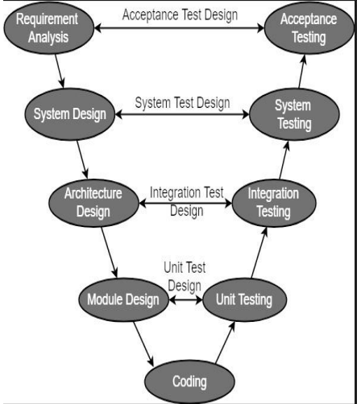 A type of SDLC model known as the V-model emphasizes the sequential execution of processes in a V-shape. The Verification and Validation model goes by a different name. Its foundation is the association of each development stage with a testing phase. The creation of each step is directly connected to the testing phase. The next phase starts once the previous phase is done, so there is a testing activity for each development activity.

**3.2.1 Verification Phases:**

The static analysis method is used in the V-Model’s concept of verification without actually running the code. At the time of development, this evaluation procedure is carried out to determine whether or not particular requirements will be met. The V-Model has several Verification phases, each described in more detail below.

* 1. **Requirement Analysis:** The cycle’s initial phase is required analysis. During this phase, requirements are gathered by assessing the users’ needs.
  2. **Functional Specification:** Preparing the plan for the system’s design or blueprint, which includes the system’s hardware, software, and network requirements.
  3. **Architectural Design:** High-Level Design (H.L.D.) is another name for this. System design and architecture are the primary focus of the H.L.D. phase. It outlines the arrangement, stage, framework, item, and administration/process.
  4. **Detail Design:** The detail design phase is also known as low-level design. Each of the designed system’s smaller units, or modules, is explained to the programmer so that they can immediately begin coding. The low-level design document or program specifications will comprehensively describe the module’s functional logic.

**3.2.2 Coding Phase** :

Following the design phase, the coding phase begins. Based on the requirements, a suitable programming language is chosen. A set of standards and guidelines govern coding. Before being checked into the repository, the final build is optimized for better performance, and the code is inspected multiple times to ensure it works.

**3.2.3 Validation Phases** :

The V-Model concept includes functional and non-functional dynamic analysis practices, and code execution is used for testing. When a product’s development is finished, validation is done to see if the software meets customer expectations. Validation Phases guarantee that all of that development was carried out appropriately. This procedure undergoes a lot of testing and is highly dynamic. These means are additionally alluded to as the ‘Tester’s life cycle.

1. **Testing Units:** Unit Test Plans (U.T.P.s) are created during the module design phase in the V-Model. These U.T.P.s are carried out to eliminate bugs at the unit or code level. A program module, for instance, is an example of the most minor, a freely existing substance known as a unit. Unit testing ensures it can function properly when the smallest unit is separated from the rest of the codes or teams.
2. **Testing Integration:** Integration testing is associated with the architectural design phase. The framework’s internal modules’ compatibility and correspondence are tested using combination tests.
3. **Testing the System:** System testing is directly linked to the design phase. System tests evaluate the communication and overall functionality of the development system.
4. **Testing for Acceptance:** Last but not least, putting all the tests created during the initial requirements phase into action is known as acceptance testing. It should ensure that the system is ready to be used and works in a natural environment with accurate data.

**3.2.4 Requirements:**

## System Requirements:

**Operating System :** Windows XP or Higher

**IDE :** VisualStudio.NET 2005/2008

**Front End :** HTML,CSS,JavaScript

**Language :** PHP

**Database :** mysql

## Hardware Requirements:

* Intel P4 1.5GHz or above
* 512MB RAM
* 80GB HDD Minimum

**3.2.5 Entity Relationship Diagram:**

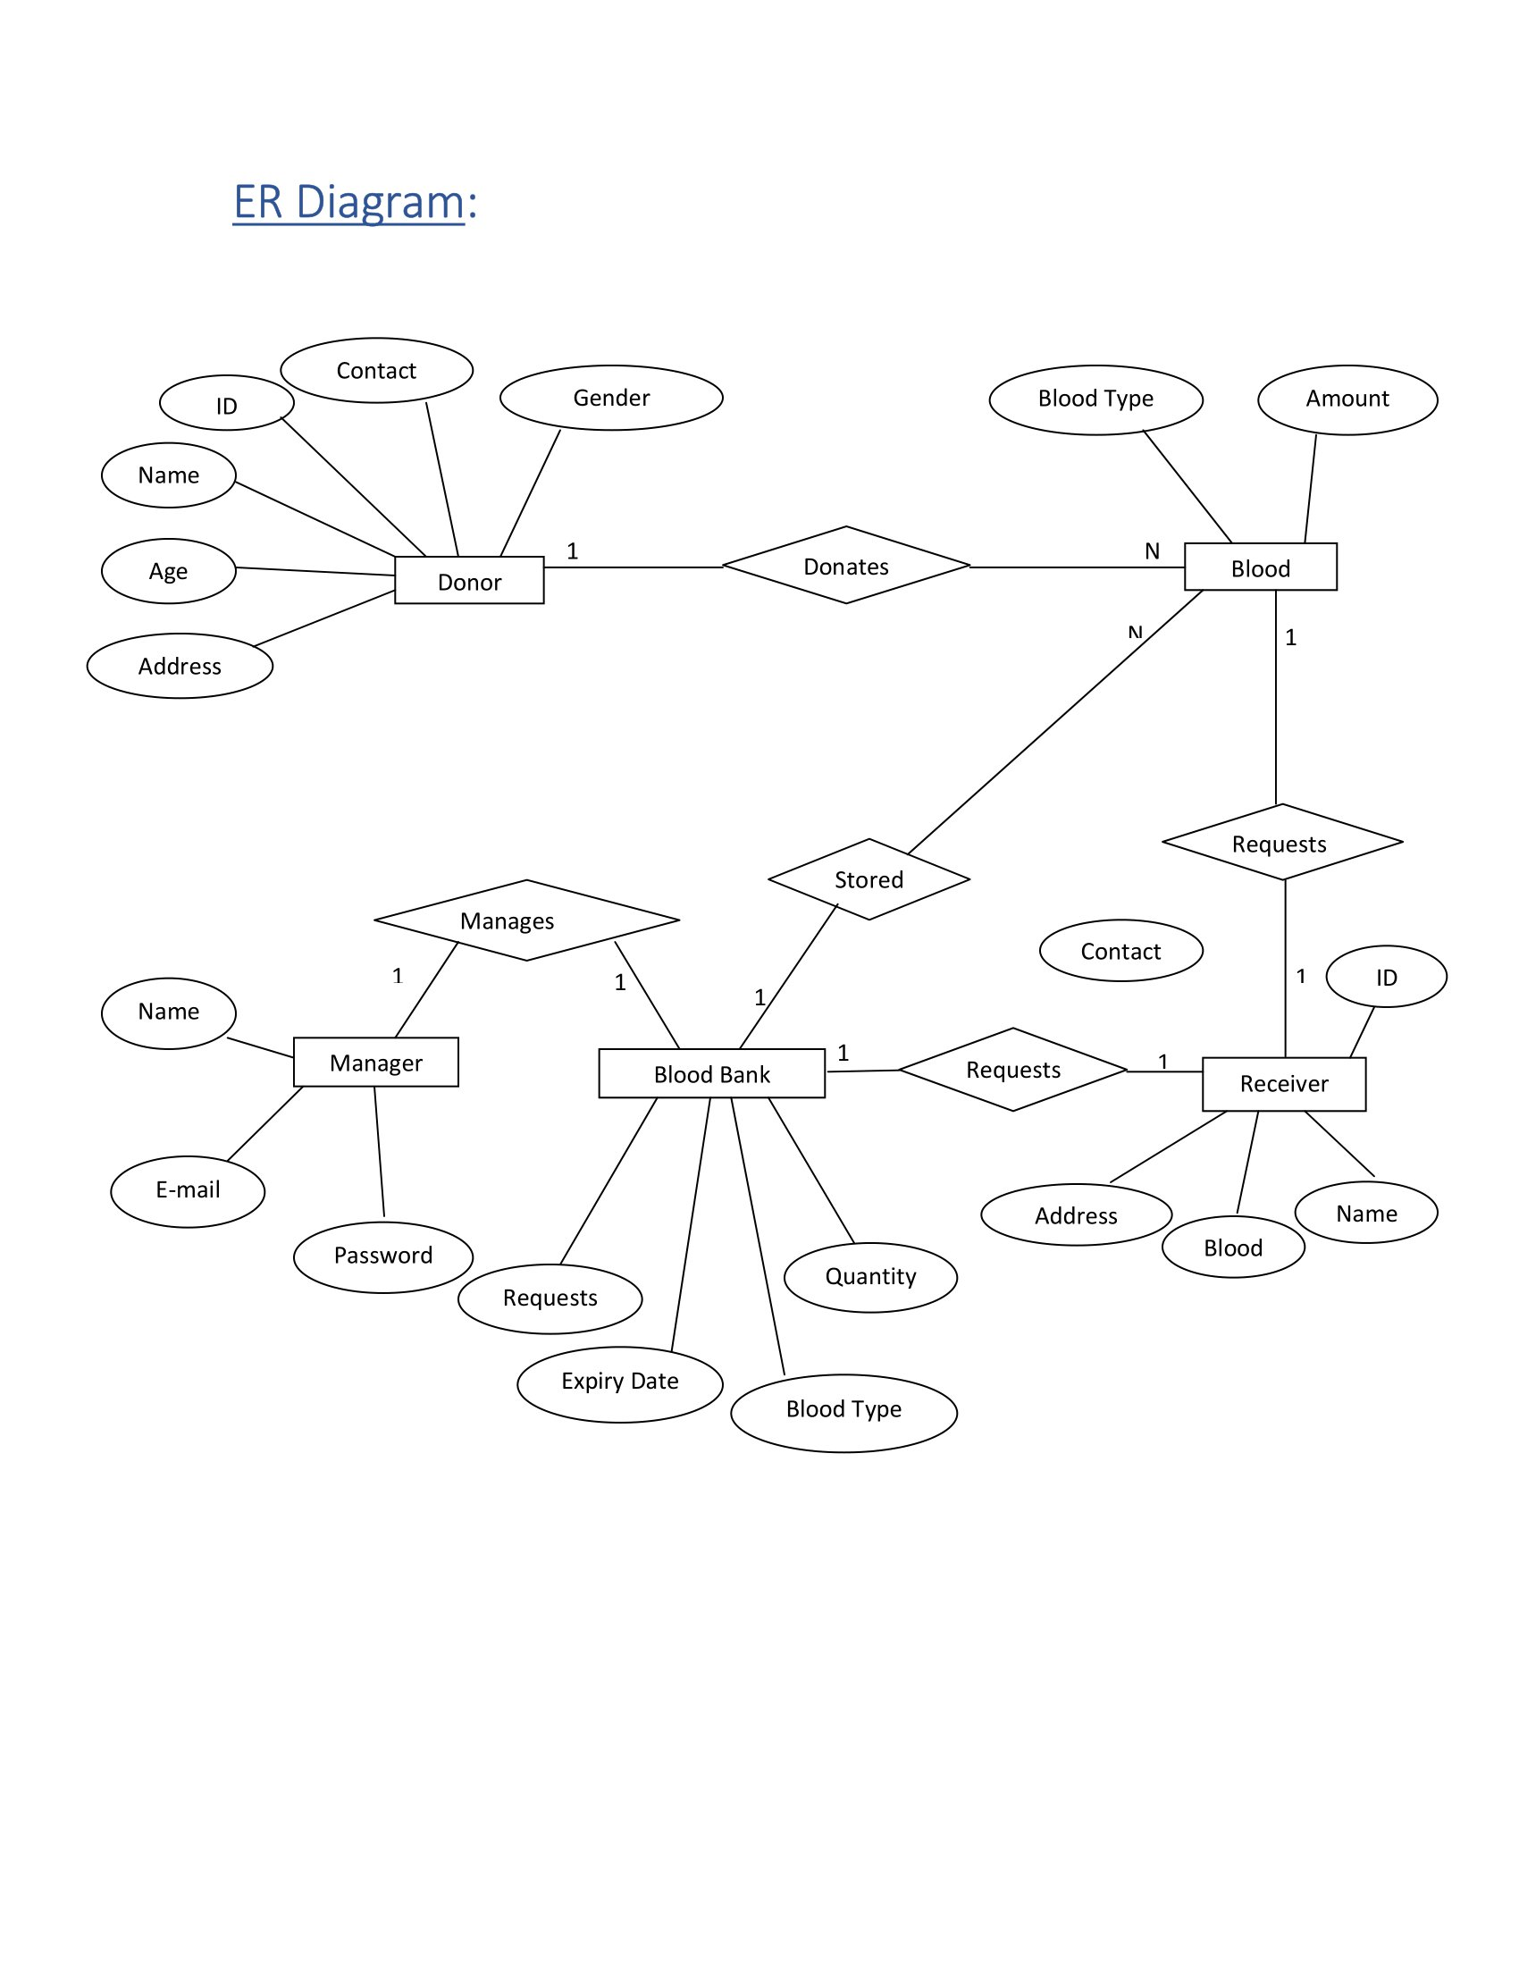

**3.2.6 USE CASE DIAGRAM :**

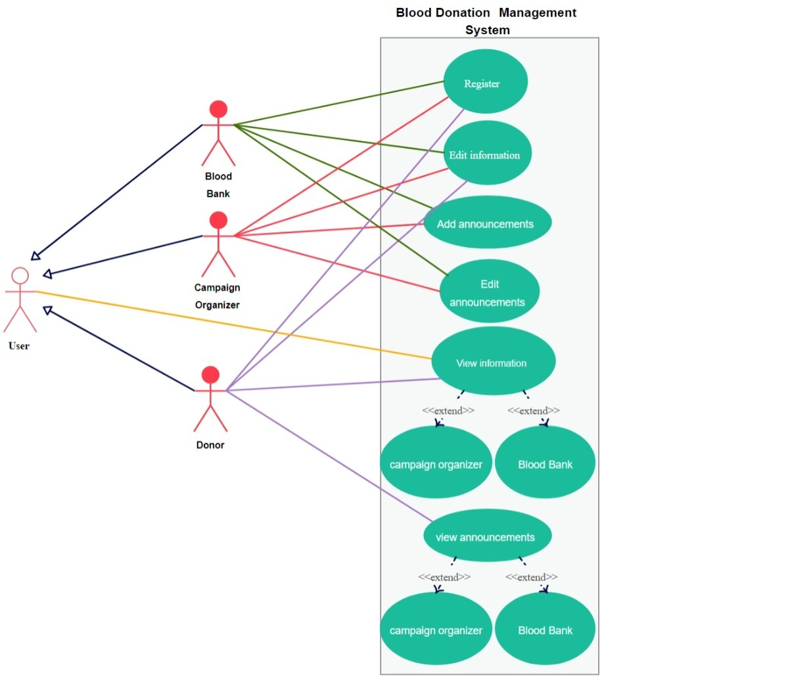 **3.2.7 DATA FLOW DIAGRAM :**

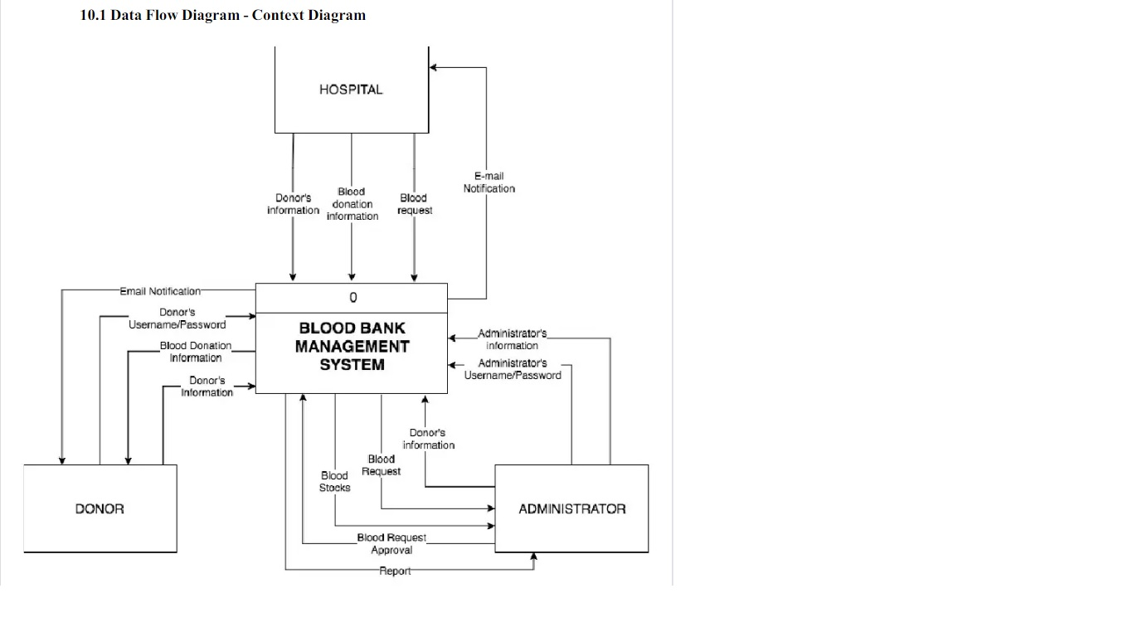

**Chapter : 4**

**PROJECT MANUAL**

Steps to Visual Studio Code:

### Step 1 :

* Download VS code from here “https://code.visualstudio.com/download”

### Step 2 :

* Download the Visual Studio Code installer for Windows. Once it is downloaded, run the installer (VSCodeUserSetup-{version}.exe). Then, run the file – it will only take a minute.

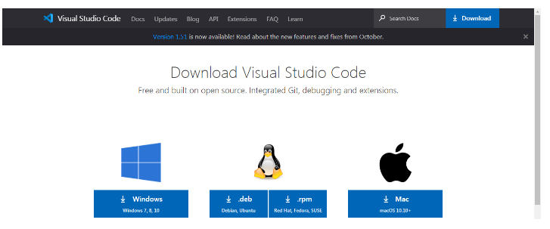

* Accept the agreement and click “next.”

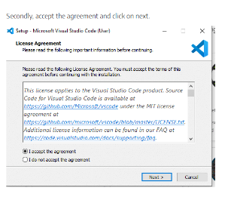

* After accepting all the requests press finish button. By default, VS Code installs under: **“C:\users{username}\AppData\Local\Programs\Microsoft VS Code.”**

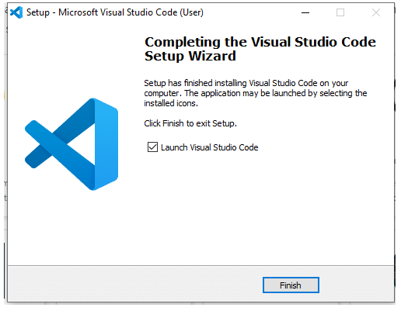

* If the installation is successful, you will see the following:

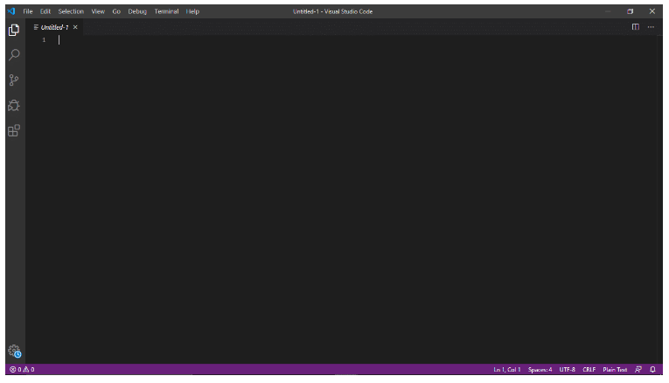

**Steps to Install XAMAPP Server:**

* Download XAMAPP executable file for Window from “<https://www.apachefreiends.org/index.html>”.

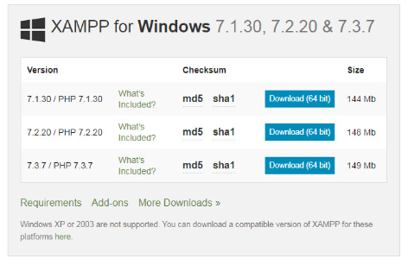

* After the download is complete, open the .exe file. Click on Next.

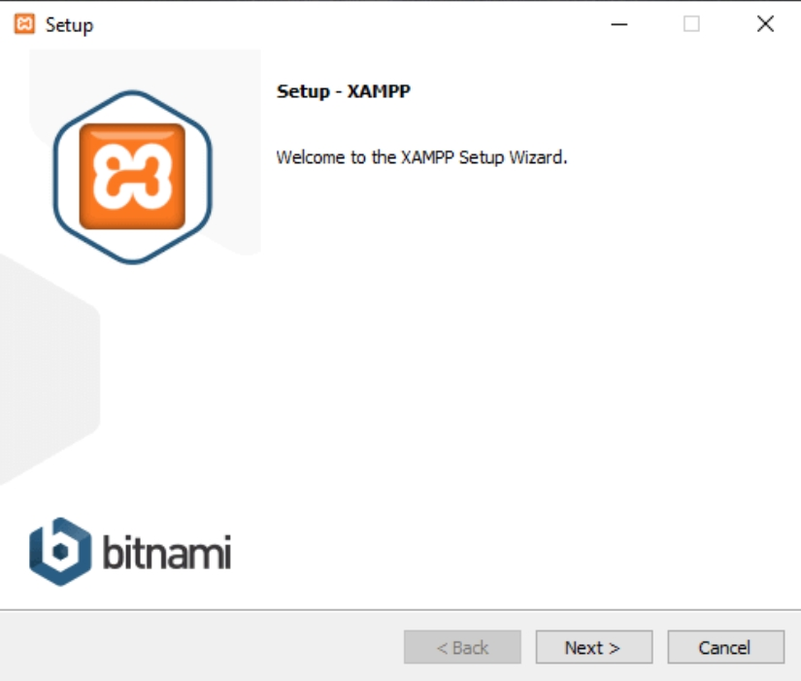

* After that, you need to select the components you want to install and then click on the Next Button.

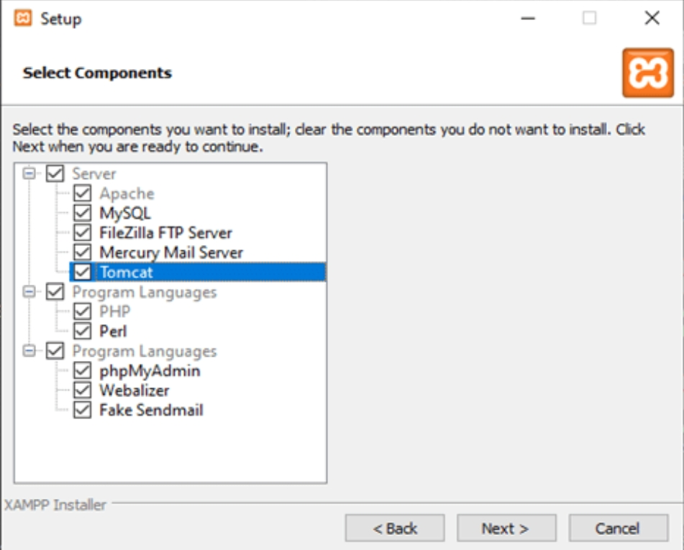

* You might into get a Security Alert on Windows. You can select the appropriate one to work for and uncheck the one that is not reqired.

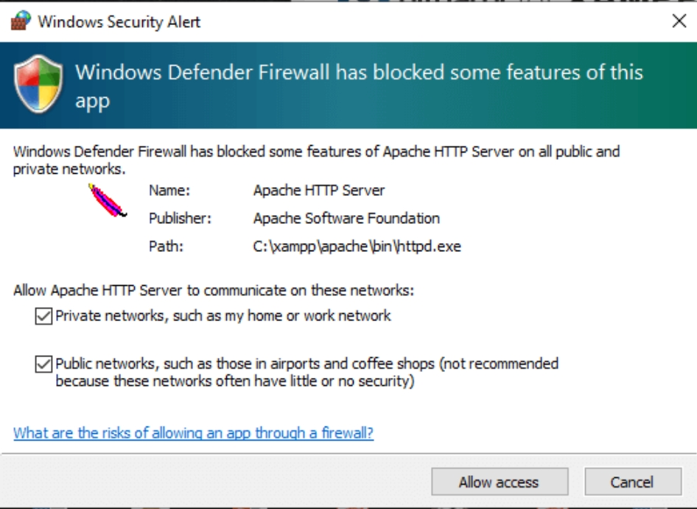

* Select your preferred language and viola ! You are done.You have successfully install XAMAPP Server. It will open the XAMAPP Control Panel, which looks like this:

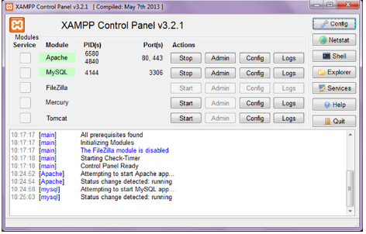

**Steps to Import SQL to phpMyAdmin:**

* Navigate to “<https://localhost/phpmyadmin>”.

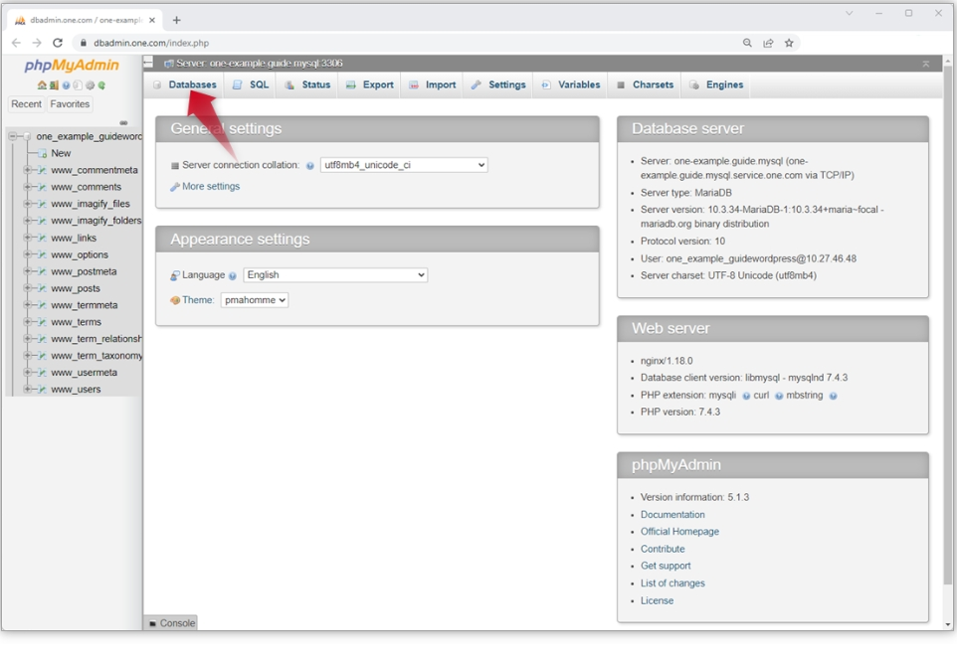

* Select the destination database on the left pane.

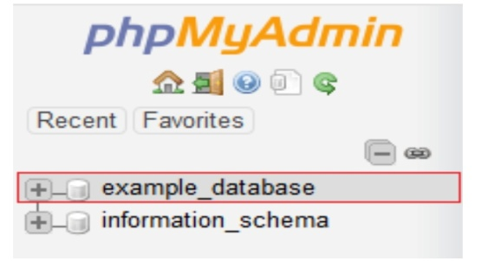

* Click on the import tab in the top center pane.

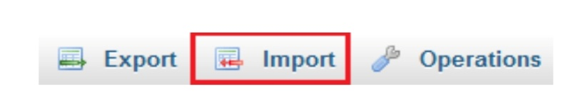

* Under the file to import section, click browse and locate the file with the “.sql” .

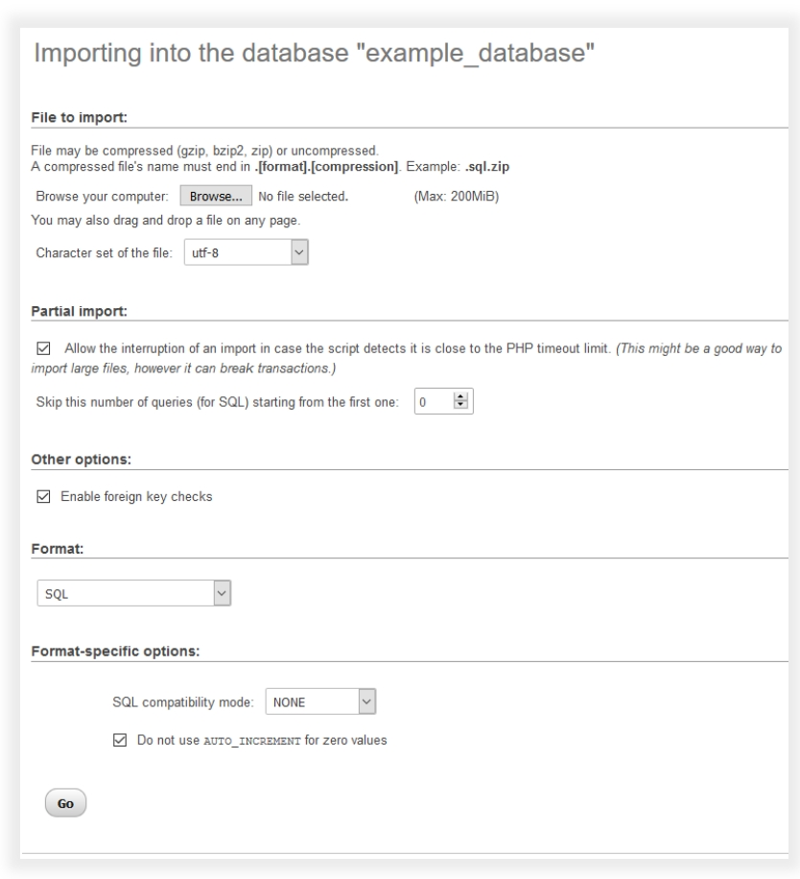

* Check or uncheck the boxes for ‘Partial import’ and ‘Other options’.
* From the Format dropdown menu choose ‘SQL’.
* Click the Go button at the bottom to import the database.

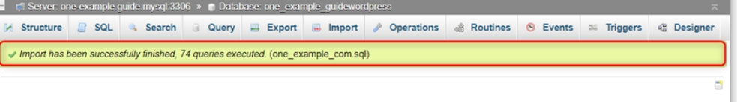

**CHAPTER:5**

**SOURCE CODE OF PROJECT**

* INDEX.html :

<!DOCTYPE html>

<html lang="en">

<head>

<meta charset="UTF-8">

<meta http-equiv="X-UA-Compatible" content="IE=edge">

<meta name="viewport" content="width=device-width, initial-scale=1.0">

<link rel="icon" href='./Images/bb_logo(white).png' type="image/png">

<link rel="stylesheet" href='index.css'>

<link rel="stylesheet" href='https://fontawesome.com/v4.7.0/icon/bars'>

<link rel="stylesheet" href="https://cdnjs.cloudflare.com/ajax/libs/font-awesome/5.15.3/css/all.min.css" />

<script src="https://cdn.jsdelivr.net/npm/bootstrap@5.1.3/dist/js/bootstrap.bundle.min.js"></script>

<script src="https://ajax.googleapis.com/ajax/libs/jquery/3.5.1/jquery.min.js"></script>

<style>

canvas {

border: 1px solid black;

}

</style>

</head>

<title>BLOOD BUDDY</title>

<div class="preloader">

<img src="pre-loader.svg" alt="spinner">

</div>

<body>

<button onclick="topFunction()" id="myBtn" class="fas fa-arrow-up"></button>

<header>

<video autoplay muted loop plays-inline id="homevideo">

<source src="./video/homevideo1.mp4" type="video/mp4">

</video>

<div id="logo"> <a href="index.html"><img src="./Images/bb_logo(white).png"></a>

</div>

<div id="nav">

<div class="header-list" id="headerl">

<i class="fa fa-times" onclick="hideMenu()"></i>

<ul>

<li><a href="about_us.html" target= "_parent">About Us</a></li>

<li><a href="volunteer.html" target= "_parent">Volunteer</a></li>

<li><a href="donate.html" target= "_parent">Donate</a></li>

<li><a href="help.html" target= "_parent">Get Help</a></li>

<li><a href="admin.html" target= "_parent">Admin</a></li>

</ul>

</div>

<i class="fa fa-bars" onclick="showMenu()"></i>

</div>

<div class="text-box">

<h1> Start </h1>

<h1>Saving Lives </h1>

<p>Become a donor or request for blood And help save lives</p>

<a href='Register.html' class="hero-btn" target="_blank">Register</a>

</div>

</header>

<canvas id="myCanvas" width="400" height="300"></canvas>

<script>

var canvas = document.getElementById("myCanvas");

var ctx = canvas.getContext("2d");

var data = [9, 6, 12, 10];

var colors = ["red", "blue", "green", "yellow"];

var x = 50;

var y = 250;

var width = 50;

var height;

for (var i = 0; i < data.length; i++) {

height = data[i] * -5;

ctx.fillStyle = colors[i];

ctx.fillRect(x, y, width, height);

ctx.fillText(data[i], x, y + 20);

x += 70;

}

</script>

<section class="customer-review">

<div class="row-customer">

<h2>Testimonials<br>See what our users have to say</h2>

</div>

<div class="row-customer">

<div class="col-customer span-1-of-3-customer customer-box">

<div class="customer-text-box">

Blood Buddy is just awesome! I just donated for the first time and it could not have been easier.Blood Buddy is doing a very important work and I'm happy that I could contribute . It's hygienic,safe and convenient, I recommend it to everyone!

</div>

<div class="customer">

<img src="Images/review-3.PNG" alt="Customer photo">

<p>Yashraj Mahapatra </p>

</div>

</div>

<div class="col-customer span-1-of-3-customer customer-box">

<div class="customer-text-box">

I found Blood Buddy at a time that my mother was in urgent need of blood. Blood Buddy arranged the required amount in no time. It saved us a lot of hassle and worry especially in such a trying time.<br> Thank you Blood Buddy!

</div>

<div class="customer">

<img src="Images/review-2.PNG" alt="Customer photo">

<p>A Sagar</p>

</div>

</div>

<div class="col-customer span-1-of-3-customer customer-box">

<div class="customer-text-box">

I have been a part of this organization for quite some time and each time I'm amazed by the seamless and efficient system in place.The importance of timely care especially in the recent times is known and having Blood Buddy takes a load off my mind.

</div>

<div class="customer">

<img src="Images/review-1.PNG" alt="Customer photo">

<p>Dr Rajat Kumar Behera</p>

</div>

</div>

</div>

</section>

<div class="siteFooterBar">

<div class="content1">

<div class="foot">2023 © All rights reserved by Yash</div>

</div>

</div>

<div class="footer-content">

<h3>JOIN OUR CAUSE</h3>

<p>Donating blood or platelets can be intimidating and even scary. Time to put those hesitations and fears aside. Learn from Blood Buddy and platelet donors how simple and easy it is to roll up a sleeve and help save lives.</p>

<div class="socials">

<ul class="sci">

<li><a href="https://www.facebook.com/INSTINCT0140" target="_blank"><i class="fab fa-facebook"></i></a> </li>

<li><a href="https://www.instagram.com/instinct_yash/" target="_blank"><I class="fab fa-instagram"></i></a></li>

<li><a href="http://localhost/dashboard/" target="_blank"><i class="fas fa-globe"></i></a></li>

</ul>

</div>

</div>

</footer>

<script>

const preloader = document.querySelector('.preloader');

const fadeEffect = setInterval(() => {

if (!preloader.style.opacity) {

preloader.style.opacity = 1;

}

if (preloader.style.opacity > 0) {

preloader.style.opacity -= 1.5;

} else {

clearInterval(fadeEffect);

}

}, 1500);

window.addEventListener('load', fadeEffect);

</script>

<script src="up.js"></script>

<script>

var headerl = document.getElementById("headerl");

function showMenu() {

headerl.style.right = "0";

}

function hideMenu() {

headerl.style.right = "-210px";

}

</script>

<script src="scroll.js"></script>

</body>

</html>

* **ABOUT.html :**

<!DOCTYPE html>

<html lang="en">

<head>

<meta charset="UTF-8">

<meta http-equiv="X-UA-Compatible" content="IE=edge">

<meta name="viewport" content="width=device-width, initial-scale=1.0">

<link rel="stylesheet" href='about.css'>

<link rel="icon" href='./Images/bb_logo(black).png' type="image/png">

<link rel="stylesheet" href="https://cdnjs.cloudflare.com/ajax/libs/font-awesome/5.15.3/css/all.min.css" />

</head>

<body>

<main>

<div id="nav">

<div class="header-list" id="headerl">

<div class="header-logo"><img src="./Images/bb_logo(black).png"></div>

<i class="fa fa-times" onclick="hideMenu()"></i>

<ul>

<li><a href="about_us.html" target= "_parent">About Us</a></li>

<li><a href="volunteer.html" target= "_parent">Volunteer</a></li>

<li><a href="donate.html" target= "_parent">Donate</a></li>

<li><a href="help.html" target= "_parent">Get Help</a></li>

<li><a href="admin.html" target= "_parent">Admin</a></li>

</ul>

</div>

<i class="fa fa-bars" onclick="showMenu()"></i>

</div><br><br><br><br><br><br><br>

<div class="sec">

<section id="about-us">

<div class="about">

<h1 class="heading">What is this all about ?</h1> <br>

<p class="head-des" class="text">We solve the problem of blood emergencies by connecting <span class="one-line"><br></span> blood donors directly with people in blood need. </p>

<div class="row">

<div class="about-col">

<div class="image">

<img src="./Images/drop.png">

</div>

<h3>What we do ?</h3>

<p>We connect blood donors with recipients, without any intermediary such as blood banks, for an efficient and seamless process.</p>

</div>

<div class="about-col">

<div class="image">

<img src="./Images/innovation.png">

</div>

<br>

<h3>Innovative</h3>

<p>Blood Buddy is an innovative approach to address global health.We provide <span>immediate access</span> to blood donors.</p>

</div>

<div class="about-col">

<div class="image">

<img src="./Images/netwotk.png">

</div>

<h3>Network</h3>

<p>Blood Buddy is one of several community organizations working together as a network that responds to emergencies in an efficient manner.</p>

</div>

<div class="about-col">

<div class="image">

<img src="./Images/noti.png">

</div>

<h3>Get notified</h3>

<p>Blood Buddy Connect works with network partners to connect blood donors and recipients through an automated SMS service and a mobile app.</p>

</div>

<div class="about-col">

<div class="image">

<img src="./Images/cost.png">

</div>

<h3>Totally Free</h3>

<p>Blood Budyy's ultimate goal is to provide an easy -to-use, easy-to-access, fast, efficient and reliable way to get life-saving blood, totally <span>Free of cost.</span></p>

</div>

<div class="about-col">

<div class="image">

<img src="./Images/save.png">

</div>

<h3>Save Life</h3>

<p>We are a non profit foundation and our main objective is to make sure that everything is done to protect vulnerable persons.<span>Help us by making a gift!</span></p>

</div>

</div>

</div>

</section>

</div>

</main>

</body>

</html>

* ABOUT.css :

@import url('https://fonts.googleapis.com/css2?family=Patrick+Hand&display=swap');

@import url('https://fonts.googleapis.com/css2?family=Josefin+Sans:ital@1&display=swap');

@import url('https://fonts.googleapis.com/css2?family=Fredoka+One&display=swap');

@import url('https://fonts.googleapis.com/css2?family=Neuton:ital@1&display=swap');

@import url('https://fonts.googleapis.com/css2?family=Patrick+Hand+SC&display=swap');

@import url('https://fonts.googleapis.com/css2?family=Alegreya+Sans+SC:wght@300&display=swap');

@import url('https://fonts.googleapis.com/css2?family=NTR&display=swap');

@import url('https://fonts.googleapis.com/css2?family=Raleway&display=swap');

*{

margin: 0;

padding: 0;

box-sizing: border-box;

}

html{

height: 100%;

}

header {

background-color: white;

color: white;

height: 18%;

width: 100%;

z-index: 10;

position: fixed;

font-weight: 100;

}

.header-logo {

font-size: 10px;

float: left;

padding-left: 30px;

padding-top: 0px;

}

.header-logo > img {

width: 70%;

}

.header-list ul li a {

text-decoration: none;

display: block;

text-decoration: none;

text-transform: uppercase;

color: black;

font-size: 20px;

font-family: 'Raleway', sans-serif;

letter-spacing: 2px;

font-weight: 600;

margin-bottom: 10px;

padding: 20px;

transition: all ease 0.5s;

}

.header-list ul li {

float: right;

padding-left: 30px;

padding-top: 30px;

list-style: none;

padding-right: 40px;

}

header ul li a:hover {

background-color: rgba(220, 20, 60);

color: white;

}

* VOLUNTEER.html :

<!DOCTYPE html> <html lang="en">

<head>

<meta charset="UTF-8">

<meta http-equiv="X-UA-Compatible" content="IE=edge">

<meta name="viewport" content="width=device-width, initial-scale=1.0">

<link rel="stylesheet" href='volunteer.css'>

<link rel="icon" href='./Images/bb_logo(black).png' type="image/png">

<link rel="stylesheet" href="https://cdnjs.cloudflare.com/ajax/libs/font-awesome/5.15.3/css/all.min.css" />

<style>

.nav-bar{

padding-top: 50%;

display: inline;

border: 2px solid;

width: 100%;

top: 0;

}

img

{

display: flex;

flex: 20%;

float: left;

}

ul{

display: flex;

flex: 80%;

float: right;

}

a{

padding-left: 20px;

text-decoration: none;

}

</style>

</head>

<title>Connect with us & save lives around your location </title>

<body>

<div class="nav-bar">

<img src="./Images/bb_logo(black).png">

<div class="header-list">

<ul>

<li><a href="help.html" target="_blank"> Get Help</a> </li>

<li><a href="admin.html" target="_blank"> Admin</a></li>

<li><a href="volunteer.html" target="_blank">Volunteer</a></li>

<li><a href="about_us.html" target="_blank">About Us</a></li>

</ul>

</div>

</div>

<br>

<br>

<br>

<div class="volunteer" section id="vol-sect">

<h1 class="title" align="center">Our Super Heroes </h1>

<p class="content">We depend on volunteers! Volunteers make up 96% of our total<span class="line"><br></span>

workforce and carry on our humanitarian work. Blood donation is healthy,<span class="line"><br></span>

our volunteers are available 24/7 to help and donate blood. Blood banks store blood<span class="line"><br></span>

bags but our volunteers are there with you in an emergency for a blood transfusion real time.</p> </div>

<div class="row">

<table>

<tr><th style="background-color: #F08080">First Name</th>

<th style="background-color: #F08080">Last Name</th>

<th style="background-color: #F08080">Points</th>

</tr>

<tr>

<td>Jill</td>

<td>SmithS</td>

<td>50</td>

</tr>

<tr>

<td>Eve</td>

<td>Jackson</td>

<td>94</td>

</tr>

<tr>

<td>Adam</td>

<td>Johnson</td>

<td>67</td>

</tr>

</table>

<table>

<tr>

<th style="background-color: #F08080">First Name</th>

<th style="background-color: #F08080">Last Name</th>

<th style="background-color: #F08080">Points</th>

</tr>

<tr>

<td>Sagar</td>

<td>Smith</td>

<td>50</td>

</tr>

<tr>

<td>Eve</td>

<td>Jackson</td>

<td>94</td>

</tr>

<tr>

<td>Adam</td>

<td>Johnson</td>

<td>67</td>

</tr>

</table> </div>

<div class="row">

<table>

<tr>

<th style="background-color: #F08080">First Name</th>

<th style="background-color: #F08080">Last Name</th>

<th style="background-color: #F08080">Points</th>

</tr>

<tr>

<td>Jill</td>

<td>Smith</td>

<td>50</td>

</tr>

<tr>

<td>Eve</td>

<td>Jackson</td>

<td>94</td>

</tr>

<tr>

<td>Adam</td>

<td>Johnson</td>

<td>67</td>

</tr>

</table>

<table>

<tr>

<th style="background-color: #F08080">First Name</th>

<th style="background-color: #F08080">Last Name</th>

<th style="background-color: #F08080">Points</th>

</tr>

<tr>

<td>Jill</td>

<td>Smith</td>

<td>50</td>

</tr>

<tr>

<td>Eve</td>

<td>Jackson</td>

<td>94</td>

</tr>

<tr>

<td>Adam</td>

<td>Johnson</td>

<td>67</td>

</tr>

</table>

</div>

<footer>

<div class="siteFooterBar">

<div class="content1">

<div class="foot">2023 © All rights reserved by YASH</div>

</div>

</div>

<div class="footer-content">

<h3>JOIN OUR CAUSE</h3>

<p>Donating blood or platelets can be intimidating and even scary. Time to put those hesitations and fears aside. Learn from Blood Buddy and platelet donors how simple and easy it is to roll up a sleeve and help save lives.</p>

<div class="socials">

<ul class="sci">

<li><a href="https://www.facebook.com/givebloodnhs/" target="_blank"><i class="fab fa-facebook"></i></a></li>

<li><a href="https://www.instagram.com/indiablooddonation/?hl=en" target="_blank"><i class="fab fa-instagram"></i></a></li>

<li><a href="http://nbtc.naco.gov.in/" target="_blank"><i class="fas fa-globe"></i></a></li> </ul>

</div>

</div>

</footer>

</body>

</html>

* VOLUNTEER.CSS :

@import url('https://fonts.googleapis.com/css2?family=Patrick+Hand&display=swap');

@import url('https://fonts.googleapis.com/css2?family=Josefin+Sans:ital@1&display=swap');

@import url('https://fonts.googleapis.com/css2?family=Fredoka+One&display=swap');

@import url('https://fonts.googleapis.com/css2?family=Neuton:ital@1&display=swap');

@import url('https://fonts.googleapis.com/css2?family=Patrick+Hand+SC&display=swap');

@import url('https://fonts.googleapis.com/css2?family=Alegreya+Sans+SC:wght@300&display=swap');

@import url('https://fonts.googleapis.com/css2?family=NTR&display=swap');

@import url('https://fonts.googleapis.com/css2?family=Raleway&display=swap');

*{

margin: 0;

padding: 0;

box-sizing: border-box;

}

html{

height: 100%;

}

body{

background: background: url('./Images/ug.png');

height: 100%;

display: flex;

justify-content: center;

align-items: center;

font-family: 'Lato', sans-serif;

flex-direction: column;

}

p{

font-family: cursive;

text-align: center;

}

content{

flex: auto;

}

table {

border-collapse: collapse;

border-spacing: 0;

width: 100%;

border: 1px solid #DDD;

}

th, td {

text-align: left;

padding: 16px;

}

tr:hover{

background-color: #F08080;

}

tr:nth-child(even) {

background-color: #f2f2f2;

}

* {

box-sizing: border-box;

}

.row{

clear: both;

display: table;

}

footer {

position: fixed;

top: 750px;

bottom: 0;

left: 0;

right: 0;

background: #111;

height: 200%;

width: 100%;

padding-top: none;

color: #fff;

padding: 10px 10px 0px 10px;

}

.footer-content {

display:flex;

align-items: center;

justify-content: center;

flex-direction: column;

text-align: center;

}

.footer-content h3 {

font-size: 1.6rem;

font-weight: 500;

text-transform: capitalize;

line-height: 3rem;

font-family: 'Raleway', sans-serif;

color: rgb(207, 205, 205);

}

.footer-content p {

max-width: fit-content;

margin: 0px 0px 0px 0px;

margin-top: 3px;

margin-bottom: 20px;

line-height: 28px;

font-size: 20px;

color: #999999;

font-family: Verdana, Geneva, Tahoma, sans-serif;

}

.footer-bottom {

background: #000;

width: 100vw;

padding: 20px;

padding-bottom: 40px;

text-align: center;

}

.footer-bottom p {

float: left;

font-size: 14px;

word-spacing: 2px;

text-transform: capitalize;

}

.footer-bottom p a {

color: #44bae8;

font-size: 16px;

text-decoration: none;

}

.footer-bottom span {

text-transform: uppercase;

opacity: .4;

font-weight: 200;

}

.footer-menu {

float: right;

}

.footer-menu ul {

display: flex;

}

.footer-menu ul li {

padding-right: 10px;

display: block;

}

.footer-menu ul li a {

color: #cfd2d6;

text-decoration: none;

}

.footer-menu ul li a:hover {

color: #27bcda;

}

.footer-content {

display: flex;

align-items: center;

justify-content: center;

flex-direction: column;

text-align: center;

}

.sci li {

float: right;

text-decoration: none;

list-style: none;

padding-right: 40px;

font-size: 30px;

}

.socials {

display: flex;

align-items: center;

padding-bottom: 2rem;

}

.sci li a {

color: white;

}

.sci li a:hover {

transform: translateY(-20px);

box-shadow: inset-1px -1px 2px rgba(0, 0, 0, 0.2), 2px 24px 10px rgba(0, 0, 0, 0.1);

}

.sci li:nth-child(1) a:hover {

color: #3b5998;

transform: translateY(-20px);

}

.sci li:nth-child(2) a:hover {

color: rgba(188, 42, 141);

transform: translateY(-20px);

}

.sci li:nth-child(3) a:hover {

color: #F0E68C;

transform: translateY(-20px);

}

.siteFooterBar {

position: absolute;

bottom: 0;

padding-top: 10px;

width: 100%;

box-shadow: 0px 0px 25px rgb(12, 12, 12);

height: 20px;

color: #9B9B9B;

background: #070707;

}

.content1 {

display: contents;

margin: 0px auto;

text-align: center;

font-size: 25px;

font-family: Verdana, Geneva, Tahoma, sans-serif;

font-size: 14px;

width: 250px;

}

.content1 .foot{

margin-top: -7px;

}

@media (max-width:500px) {

.footer-menu ul {

display: flex;

margin-top: 10px;

margin-bottom: 20px;

}

.sci li {

padding-right: 15px;

font-size: 25px;

}

}

@media screen and (max-width: 360px) {

.sci li {

padding-right: 7px;

font-size: 20px;

}

}

@media screen and (max-width: 500px) {

.head {

padding-left: 15px;

font-size: 30px;

font-weight: 550;

}

.sci li {

padding-right: 15px;

font-size: 25px;

}

}

@media screen and (max-width: 360px) {

.head {

padding-left: 7px;

font-size: 25px;

}

.sci li {

padding-right: 7px;

font-size: 20px;

}

.bout p {

font-size: 18px;

}

.bout {

padding-left: 2px;

padding-right: 2px;

}

}

* DONATE.html :

<!DOCTYPE html>

<html lang="en">

<head>

<meta charset="UTF-8">

<meta http-equiv="X-UA-Compatible" content="IE=edge">

<meta name="viewport" content="width=device-width, initial-scale=1.0">

<link rel="stylesheet" href='donate.css'>

<link rel="icon" href='./Images/bb_logo(black).png' type="image/png">

<link rel="stylesheet" href="https://cdnjs.cloudflare.com/ajax/libs/font-awesome/5.15.3/css/all.min.css" />

</head>

<title>Connect with us & save lives around your location </title>

<body>

<header>

<nav>

<div class="header-logo"><img src="./Images/bb_logo(black).png"></div>

<div class="header-list">

<ul>

<li><a href="help.html" target="_blank"> Get Help</a></li>

<li><a href="admin.html" target="_blank"> Admin</a></li>

<li><a href="volunteer.html" target="_blank">Volunteer</a></li>

<li><a href="about_us.html" target="_blank">About Us</a></li>

</ul>

</div>

</nav>

</header>

<main>

<div class="box">

<h2>Connect with us & save lives

around your location</h2>

<ul class="des">

<li class="steps"><span>1</span> Register🧍🏻</li>

<li class="steps"><span>2</span> Post a Blood request🩸 </li>

<li class="steps"><span>3</span> Respond ✅ </li>

<li class="steps"><span>4</span> Get notified 📱</li>

<li class="steps"><span>5</span> Forever Free 💲❌ </li>

<li class="steps"><span>6</span> Save a Life 🩸🧬</li>

</ul>

<div class="text-box">

<a href="Register.html" class="hero-btn" target="_blank">Register</a>

</div>

</div>

</main>

<footer>

<div class="siteFooterBar">

<div class="content1">

<div class="foot">2023 © All rights reserved by YASH</div>

</div>

</div>

<div class="footer-content">

<h3>JOIN OUR CAUSE</h3>

<p>Donating blood or platelets can be intimidating and even scary. Time to put those hesitations and fears aside. Learn from Blood Buddy and platelet donors how simple and easy it is to roll up a sleeve and help save lives.</p>

<div class="socials">

<ul class="sci">

<li><a href="https://www.facebook.com/givebloodnhs/" target="_blank"><i

class="fab fa-facebook"></i></a></li>

<li><a href="https://www.instagram.com/indiablooddonation/?hl=en" target="_blank"><i

class="fab fa-instagram"></i></a></li>

<li><a href="http://nbtc.naco.gov.in/" target="_blank"><i class="fas fa-globe"></i></a></li>

</ul>

</div>

</div>

</footer>

</body>

</html>

* DONATE.css :

@import url('https://fonts.googleapis.com/css2?family=Patrick+Hand&display=swap');

@import url('https://fonts.googleapis.com/css2?family=Josefin+Sans:ital@1&display=swap');

@import url('https://fonts.googleapis.com/css2?family=Fredoka+One&display=swap');

@import url('https://fonts.googleapis.com/css2?family=Neuton:ital@1&display=swap');

@import url('https://fonts.googleapis.com/css2?family=Patrick+Hand+SC&display=swap');

@import url('https://fonts.googleapis.com/css2?family=Alegreya+Sans+SC:wght@300&display=swap');

@import url('https://fonts.googleapis.com/css2?family=NTR&display=swap');

@import url('https://fonts.googleapis.com/css2?family=Raleway&display=swap');

* {

margin: 0px;

padding: 0;

}

header {

background-color: white;

color: white;

height: 18%;

width: 100%;

z-index: 10;

position: fixed;

font-weight: 100;

}

.header-logo {

font-size: 10px;

float: left;

padding-left: 30px;

padding-top: 0px;

}

.header-logo > img {

width: 70%;

}

.header-list ul li a {

text-decoration: none;

display: block;

text-decoration: none;

text-transform: uppercase;

color: black;

font-size: 20px;

font-family: 'Raleway', sans-serif;

letter-spacing: 2px;

font-weight: 600;

margin-bottom: 10px;

padding: 20px;

transition: all ease 0.5s;

}

.header-list ul li {

float: right;

padding-left: 30px;

padding-top: 30px;

list-style: none;

padding-right: 40px;

}

.des{

font-size: 24px;

}

header ul li a:hover {

background-color: rgba(220, 20, 60);

color: white;

}

main {

display: flex;

justify-content: center;

align-items: center;

background: #f6f6f6;

height: 70%;

}

.box {

width: 500px;

padding-top: 15%;

border-bottom-left-radius: 10px;

border-bottom-right-radius: 10px;

border-bottom: 20px solid #DC143C;

}

.box h2 {

color: #fff;

background: #DC143C;

padding: 14px 19px;

font-size: 20px;

font-weight: 700;

border-top-left-radius: 10px;

border-top-right-radius: 10px;

font-family: 'Josefin Sans', sans-serif;

text-align: center;

}

.box .des li {

list-style: none;

padding: 10px;

width: 96%;

background: #fff;

box-shadow: 0 5px 25px rgba(0, 0, 0, 0.1);

transition: transform 0.5s;

font-family: 'Patrick Hand', cursive;

}

.box .des li:hover {

transform: scale(1.1);

z-index: 100;

background: #DB7093;

box-shadow: 0 5px 25px rgba(0, 0, 0, 0.2);

color: #fff;

cursor: pointer;

}

.box .des li span {

width: 20px;

height: 20px;

text-align: center;

line-height: 20px;

background: #DB7093;

color: #fff;

display: inline-block;

border-radius: 50%;

margin-right: 10px;

font-size: 12px;

font-weight: 600;

transform: translateY(-2px);

}

.box .des li:hover span {

background: #fff;

color: #DB7093;

}

main {

background: url(./Images/div.jpg);

}

.hero-btn {

display: inline-block;

text-decoration: none;

color: black;

border: 1px solid #fff;

padding: 12px 29px;

font-size: 20px;

background: transparent;

position: relative;

cursor: pointer;

width: 15vh;

letter-spacing: 4px;

height: 8vh;

font-family: 'Patrick Hand SC', cursive;

}

.text-box {

width: 100%;

color: #fff;

text-align: center;

font-family: 'Neuton', serif;

border: none;

}

.hero-btn:hover {

border: 1px solid #DC143C;

background: #DC143C;

transition: 1s;

color: #fff;

width: 88%;

}

.sec {

border-top-left-radius: 40px;

background: black;

margin-top: 2%;

color: #FFB6C1 ;

height: 200px;

padding-bottom: 20px;

display: flex;

flex-direction: column;

}

.footer-head {

display: flex;

justify-content: space-around;

padding-top: 4vh;

}

.bout p{

font-size: 18px;

color: white;

font-weight: 100;

}

.bout {

position: relative;

padding-right: 20px;

padding-left: 20px;

text-align: center;

padding-top: 1vh;

}

.head {

padding-left: 20px;

font-family: 'Alegreya Sans SC', sans-serif;

font-size: 40px;

font-weight: 600;

display: flex;

align-items: center;

}

.head:hover{

color: white;

}

.sci li {

float: right;

text-decoration: none;

list-style: none;

padding-right: 40px;

font-size: 30px;

}

.socials {

display: flex;

align-items: center;

}

.sci li a {

color: white;

}

.sci li a:hover {

transition: 1s;

box-shadow: inset-1px -1px 2px rgba(0, 0, 0, 0.2), 2px 24px 10px rgba(0, 0, 0, 0.1);

}

.sci li i{

transition: .5s;

}

.sci li i:hover{

transform: rotate(0deg) skew(0deg) translate(0, -10px);

}

.sci li:nth-child(1) a:hover {

color: #3b5998;

transform: translateY(-20%);

}

.sci li:nth-child(2) a:hover {

color: rgba(188, 42, 141);

transform: translateY(-20px);

}

.sci li:nth-child(3) a:hover {

color: #F0E68C;

transform: translateY(-20px);

}

footer {

position: relative;

top: 70px;

bottom: 0;

left: 0;

right: 0;

background: #111;

height: 200%;

width: 100%;

padding-top: none;

color: #fff;

/*padding: 5px 0px 5px 0px;*/

}

.footer-content {

display: flex;

align-items: center;

justify-content: center;

flex-direction: column;

text-align: center;

}

.footer-content h3 {

font-size: 1.6rem;

font-weight: 500;

text-transform: capitalize;

line-height: 3rem;

font-family: 'Raleway', sans-serif;

color: rgb(207, 205, 205);

}

.footer-content p {

max-width: fit-content;

margin: 0px 0px 0px 0px;

margin-top: 3px;

margin-bottom: 20px;

line-height: 28px;

font-size: 20px;

color: #999999;

font-family: Verdana, Geneva, Tahoma, sans-serif;

}

.footer-bottom {

background: #000;

width: 100vw;

padding: 20px;

padding-bottom: 40px;

text-align: center;

}

.footer-bottom p {

float: left;

font-size: 14px;

word-spacing: 2px;

text-transform: capitalize;

}

.footer-bottom p a {

color: #44bae8;

font-size: 16px;

text-decoration: none;

}

.footer-bottom span {

text-transform: uppercase;

opacity: .4;

font-weight: 200;

}

.footer-menu {

float: right;

}

.footer-menu ul {

display: flex;

}

.footer-menu ul li {

padding-right: 10px;

display: block;

}

.footer-menu ul li a {

color: #cfd2d6;

text-decoration: none;

}

.footer-menu ul li a:hover {

color: #27bcda;

}

.footer-content {

display: flex;

align-items: center;

justify-content: center;

flex-direction: column;

text-align: center;

}

.sci li {

float: right;

text-decoration: none;

list-style: none;

padding-right: 40px;

font-size: 30px;

}

.socials {

display: flex;

align-items: center;

padding-bottom: 2rem;

}

.sci li a {

color: white;

}

.sci li a:hover {

transform: translateY(-20px);

box-shadow: inset-1px -1px 2px rgba(0, 0, 0, 0.2), 2px 24px 10px rgba(0, 0, 0, 0.1);

}

.sci li:nth-child(1) a:hover {

color: #3b5998;

transform: translateY(-20px);

}

.sci li:nth-child(2) a:hover {

color: rgba(188, 42, 141);

transform: translateY(-20px);

}

.sci li:nth-child(3) a:hover {

color: #F0E68C;

transform: translateY(-20px);

}

.siteFooterBar {

position: absolute;

bottom: 0;

padding-top: 10px;

width: 100%;

box-shadow: 0px 0px 25px rgb(12, 12, 12);

height: 20px;

color: #9B9B9B;

background: #070707;

}

.content1 {

display: contents;

margin: 0px auto;

text-align: center;

font-size: 25px;

font-family: Verdana, Geneva, Tahoma, sans-serif;

font-size: 14px;

width: 250px:

}

.content1 .foot{

margin-top: -7px;

}

@media (max-width:500px) {

.footer-menu ul {

display: flex;

margin-top: 10px;

margin-bottom: 20px;

}

.sci li {

padding-right: 15px;

font-size: 25px;

}

}

@media screen and (max-width: 360px) {

.sci li {

padding-right: 7px;

font-size: 20px;

}

}

@media screen and (max-width: 500px) {

.head {

padding-left: 15px;

font-size: 30px;

font-weight: 550;

}

.sci li {

padding-right: 15px;

font-size: 25px;

}

}

@media screen and (max-width: 360px) {

.head {

padding-left: 7px;

font-size: 25px;

}

.sci li {

padding-right: 7px;

font-size: 20px;

}

.bout p {

font-size: 18px;

}

.bout {

padding-left: 2px;

padding-right: 2px;

}

}

* HELP.html :

<!DOCTYPE html>

<html lang="en">

<head>

<meta charset="UTF-8">

<meta http-equiv="X-UA-Compatible" content="IE=edge">

<meta name="viewport" content="width=device-width, initial-scale=1.0">

<link rel="stylesheet" href='help.css'>

<link rel="icon" href='./Images/bb_logo(black).png' type="image/png">

<link rel="stylesheet" href="https://cdnjs.cloudflare.com/ajax/libs/font-awesome/5.15.3/css/all.min.css" />

</head>

<title>Connect with us </title>

<body>

<header>

<nav>

<div class="header-logo"><img src="./Images/bb_logo(black).png"></div>

<div class="header-list">

<ul>

<li><a href="help.html">Get Help</a></li>

<li><a href="donate.html">Donate</a></li>

<li><a href="index.html#vol-sect">Volunteer</a></li>

<li><a href="index.html#about-us">About Us</a></li>

</ul>

</div>

</nav>

</header>

<main>

<div class="container">

<div class="contact-box">

<div class="left"></div>

<div class="right">

<h2>Connect with us </h2>

<input type="text" class="field" placeholder="Your Name">

<input type="text" class="field" placeholder="Your Email">

<input type="text" class="field" placeholder="Phone">

<textarea placeholder="Message" class="field"></textarea>

<button class="btn">Send</button>

</div>

</div>

</div>

</main>

<footer>

<div class="siteFooterBar">

<div class="content1">

<div class="foot">2021 © All rights reserved.</div>

</div>

</div>

<div class="footer-content">

<h3>JOIN OUR CAUSE</h3>

<p>Donating blood or platelets can be intimidating and even scary. Time to put those hesitations and fears aside. Learn from Blood Buddy and platelet donors how simple and easy it is to roll up a sleeve and help save lives.</p>

<div class="socials">

<ul class="sci">

<li><a href="https://www.facebook.com/givebloodnhs/" target="_blank"><i

class="fab fa-facebook"></i></a></li>

<li><a href="https://www.instagram.com/indiablooddonation/?hl=en" target="_blank"><i

class="fab fa-instagram"></i></a></li>

<li><a href="http://nbtc.naco.gov.in/" target="_blank"><i class="fas fa-globe"></i></a></li>

</ul>

</div>

</div>

</footer>

</body>

</html>

* HELP.css :

@import url('https://fonts.googleapis.com/css2?family=Patrick+Hand&display=swap');

@import url('https://fonts.googleapis.com/css2?family=Josefin+Sans:ital@1&display=swap');

@import url('https://fonts.googleapis.com/css2?family=Fredoka+One&display=swap');

@import url('https://fonts.googleapis.com/css2?family=Neuton:ital@1&display=swap');

@import url('https://fonts.googleapis.com/css2?family=Patrick+Hand+SC&display=swap');

@import url('https://fonts.googleapis.com/css2?family=Alegreya+Sans+SC:wght@300&display=swap');

@import url('https://fonts.googleapis.com/css2?family=NTR&display=swap');

@import url('https://fonts.googleapis.com/css2?family=Raleway&display=swap');

* {

margin: 0px;

}

header{

background-color: white;

color: white;

height: 18%;

width: 100%;

z-index: 10;

position: fixed;

font-weight: 100;

}

.header-logo{

font-size: 10px;

float: left;

padding-left: 30px;

padding-top: 0px;

padding-bottom: 12%;

}

.header-logo > img {

width: 70%;

}

.header-list ul li a {

text-decoration: none;

display: block;

text-decoration: none;

text-transform: uppercase;

color: black;

font-size: 20px;

font-family: 'Raleway', sans-serif;

letter-spacing: 2px;

font-weight: 600;

margin-bottom: 10px;

padding: 20px;

transition: all ease 0.5s;

}

.header-list ul li {

float: right;

padding-left: 30px;

padding-top: 30px;

list-style: none;

padding-right: 40px;

}

header ul li a:hover{

background-color:rgba(220,20,60);

color: white;

}

.container{

position: relative;

width: 100%;

height: 100%;

display: flex;

justify-content: center;

align-items: center;

padding-top: 20%;

}

.container:after{

content: '';

position: absolute;

width: 100%;

height: 100%;

left: 0;

top: 0;

background: url("img/bg.jpg") no-repeat center;

background-size: cover;

filter: blur(50px);

z-index: -1;

}

.contact-box{

max-width: 850px;

display: grid;

grid-template-columns: repeat(2, 1fr);

justify-content: center;

align-items: center;

text-align: center;

background-color: #fff;

box-shadow: 0px 0px 19px 5px rgba(0,0,0,0.19);

padding-right: 10px;

}

.left{

background: url(./Images/help.jpg) no-repeat center;

background-size: cover;

height: 100%;

}

.right{

padding: 25px 40px;

}

h2{

position: relative;

padding: 0 0 10px;

margin-bottom: 10px;

font-family: 'Advent Pro', sans-serif;

}

h2:after{

content: '';

position: absolute;

left: 50%;

bottom: 0;

transform: translateX(-50%);

height: 4px;

width: 50px;

border-radius: 2px;

background-color: #008B8B;

}

.field{

width: 100%;

border: 2px solid rgba(0, 0, 0, 0);

outline: none;

background-color: rgba(230, 230, 230, 0.6);

padding: 0.5rem 1rem;

font-size: 1.1rem;

margin-bottom: 22px;

transition: .3s;

}

.field:hover{

background-color: rgba(0, 0, 0, 0.1);

}

textarea{

min-height: 150px;

}

.btn{

width: 100%;

padding: 0.5rem 1rem;

background-color:#008B8B;

color: #fff;

font-size: 1.1rem;

border: none;

outline: none;

cursor: pointer;

transition: .3s;

}

.btn:hover{

background-color: rgba(72,61,139);

}

.field:focus{

border: 2px solid rgba(30,85,250,0.47);

background-color: #fff;

}

@media screen and (max-width: 880px){

.contact-box{

grid-template-columns: 1fr;

}

.left{

height: 200px;

} }

main{

background: url(../Images/ug.png);

}

.sec {

border-top-left-radius: 40px;

background: black;

margin-top: 2%;

color: #FFB6C1 ;

height: 200px;

padding-bottom: 20px;

display: flex;

flex-direction: column;

}

.footer-head {

display: flex;

justify-content: space-around;

padding-top: 4vh;

}

.bout p{

font-size: 18px;

color: white;

font-weight: 100;

}

.bout {

position: relative;

padding-right: 20px;

padding-left: 20px;

text-align: center;

padding-top: 1vh;

}

.head {

padding-left: 20px;

font-family: 'Alegreya Sans SC', sans-serif;

font-size: 40px;

font-weight: 600;

display: flex;

align-items: center;

}

.head:hover{

color: white;

}

.sci li {

float: right;

text-decoration: none;

list-style: none;

padding-right: 40px;

font-size: 30px;

}

.socials {

display: flex;

align-items: center;

}

.sci li a {

color: white;

}

.sci li a:hover {

transition: 1s;

box-shadow: inset-1px -1px 2px rgba(0, 0, 0, 0.2), 2px 24px 10px rgba(0, 0, 0, 0.1);

}

.sci li i{

transition: .5s;

}

.sci li i:hover{

transform: rotate(0deg) skew(0deg) translate(0, -10px);

}

.sci li:nth-child(1) a:hover {

color: #3b5998;

transform: translateY(-20%);

}

.sci li:nth-child(2) a:hover {

color: rgba(188, 42, 141);

transform: translateY(-20px);

}

.sci li:nth-child(3) a:hover {

color: #F0E68C;

transform: translateY(-20px);

}

@media screen and (max-width: 500px) {

.head {

padding-left: 15px;

font-size: 30px;

font-weight: 550;

}

.sci li {

padding-right: 15px;

font-size: 25px;

}

}

@media screen and (max-width: 360px) {

.head {

padding-left: 7px;

font-size: 25px;

}

.sci li {

padding-right: 7px;

font-size: 20px;

}

.bout p {

font-size: 18px;

}

.bout {

padding-left: 2px;

padding-right: 2px;

}

}

footer {

position: relative;

top: 70px;

bottom: 0;

left: 0;

right: 0;

background: #111;

height: 200%;

width: 100%;

padding-top: none;

color: #fff;

}

.footer-content {

display: flex;

align-items: center;

justify-content: center;

flex-direction: column;

text-align: center;

}

.footer-content h3 {

font-size: 1.6rem;

font-weight: 500;

text-transform: capitalize;

line-height: 3rem;

font-family: 'Raleway', sans-serif;

color: rgb(207, 205, 205);

}

.footer-content p {

max-width: fit-content;

margin: 0px 0px 0px 0px;

margin-top: 5px;

margin-bottom: 20px;

line-height: 28px;

font-size: 20px;

color: #999999;

font-family: Verdana, Geneva, Tahoma, sans-serif;

}

.footer-bottom {

background: #000;

width: 100vw;

padding: 20px;

padding-bottom: 40px;

text-align: center;

}

.footer-bottom p {

float: left;

font-size: 14px;

word-spacing: 2px;

text-transform: capitalize;

}

.footer-bottom p a {

color: #44bae8;

font-size: 16px;

text-decoration: none;

}

.footer-bottom span {

text-transform: uppercase;

opacity: .4;

font-weight: 200;

}

.footer-menu {

float: right;

}

.footer-menu ul {

display: flex;

}

.footer-menu ul li {

padding-right: 10px;

display: block;

}

.footer-menu ul li a {

color: #cfd2d6;

text-decoration: none;

}

.footer-menu ul li a:hover {

color: #27bcda;

}

.footer-content {

display: flex;

align-items: center;

justify-content: center;

flex-direction: column;

text-align: center;

}

.sci li {

float: right;

text-decoration: none;

list-style: none;

padding-right: 40px;

font-size: 30px;

}

.socials {

display: flex;

align-items: center;

padding-bottom: 2rem;

}

.sci li a {

color: white;

}

.sci li a:hover {

transform: translateY(-20px);

box-shadow: inset-1px -1px 2px rgba(0, 0, 0, 0.2), 2px 24px 10px rgba(0, 0, 0, 0.1);

}

.sci li:nth-child(1) a:hover {

color: #3b5998;

transform: translateY(-20px);

}

.sci li:nth-child(2) a:hover {

color: rgba(188, 42, 141);

transform: translateY(-20px);

}

.sci li:nth-child(3) a:hover {

color: #F0E68C;

transform: translateY(-20px);

}

.siteFooterBar {

position: absolute;

bottom: 0;

padding-top: 10px;

width: 100%;

box-shadow: 0px 0px 25px rgb(12, 12, 12);

height: 20px;

color: #9B9B9B;

background: #070707;

}

.content1 {

display: contents;

margin: 0px auto;

text-align: center;

font-size: 25px;

font-family: Verdana, Geneva, Tahoma, sans-serif;

font-size: 14px;

width: 250px;

}

.content1 .foot{

margin-top: -7px;

}

@media (max-width:500px) {

.footer-menu ul {

display: flex;

margin-top: 10px;

margin-bottom: 20px;

}

.sci li {

padding-right: 15px;

font-size: 25px;

}

}

@media screen and (max-width: 360px) {

.sci li {

padding-right: 7px;

font-size: 20px;

}

}

@media screen and (max-width: 500px) {

.head {

padding-left: 15px;

font-size: 30px;

font-weight: 550;

}

.sci li {

padding-right: 15px;

font-size: 25px;

}

}

@media screen and (max-width: 360px) {

.head {

padding-left: 7px;

font-size: 25px;

}

.sci li {

padding-right: 7px;

font-size: 20px;

}

.bout p {

font-size: 18px;

}

.bout {

padding-left: 2px;

padding-right: 2px;

}

}

* ADMIN.html :

<!DOCTYPE html>

<?php

session_start();

if (isset($_SESSION['authenticated']) && $_SESSION['authenticated'] == true) {

header('Location: admin.php'); // Redirect to the dashboard page

exit();

}

?>

<html lang="en">

<head>

<meta charset="UTF-8">

<meta http-equiv="X-UA-Compatible" content="IE=edge">

<meta name="viewport" content="width=device-width, initial-scale=1.0">

<link rel="stylesheet" href='admin.css'>

<link rel="icon" href='./Images/bb_logo(black).png' type="image/png">

<link rel="stylesheet" href="https://cdnjs.cloudflare.com/ajax/libs/font-awesome/5.15.3/css/all.min.css"/>

<title>Blood Bank Admin Page</title>

<style media="screen">

form {

padding: 20px 40px;

}

.form-group {

position: relative;

padding: 20px 0;

width: 300px;

max-width: 100%;

}

.form-group input {

background-color: transparent;

border: none;

border-bottom: 1px solid #9e9e9e;

color: #333;

font-size: 16px;

padding: 10px 0;

display: block;

width: 100%;

}

.form-group label {

color: #9e9e9e;

font-size: 16px;

font-weight: 100;

position: absolute;

pointer-events: none;

top: 0;

transform: translateY(30px);

transition: all 0.3s ease-in-out;

left: 0px;

}

.form-group input:valid,

.form-group input:focus {

border-bottom-color: #F08080;

outline: 1px;

}

.form-group input:valid + label,

.form-group input:focus + label {

color: #ee6e73;

font-size: 14px;

transform: translateY(0);

}

input[type="button"] {

background-color: #ee6e73;

border: 2px solid #ee6e73;

border-radius: 20px;

box-sizing: border-box;

color: #fff;

cursor: pointer;

font-size: 16px;

padding: 15px 0;

margin-top: 15px;

width: 100%;

}

input[type="button"]:hover {

background-color: #084ccd;

border: 2px solid #084ccd;

}

input[type="button"]: active {

border-color: #f08080;

}

input[type="button"]:focus {

outline: none;

}

</style>

</head>

<body>

<header>

<nav>

<div class="header-logo"><img src="./Images/bb_logo(black).png"></div>

<div class="header-list">

<ul>

<li><a href="help.html">Get Help</a></li>

<li><a href="donate.html">Donate</a></li>

<li><a href="index.html#vol-sect">Volunteer</a></li>

<li><a href="index.html#about-us">About Us</a></li>

</ul>

</div>

</nav>

</header>

<div class="admin-login">

<h1>Register</h1>

<div class="login-box">

<form action="auth.php" id="log" method="POST">

<div class="form-group">

<input type="text" name="user" required/><label>Name</label> </div>

<div class="form-group">

<input type="email" name="email" required/><label>E-mail</label> </div>

<div class="form-group">

<input type="password" name="pass" required/><label>Password</label></div>

<input type="button" value="Submit" />

</form>

</div>

</div>

</body>

</html>

* ADMIN.css :

*{

margin: 0;

padding: 0;

box-sizing: border-box;

}

html{

height: 100%;

}

body{

background: background: url('./Images/ug.png');

height: 100%;

display: flex;

justify-content: center;

align-items: center;

font-family: 'Lato', sans-serif;

flex-direction: column;

}

header {

background: background: url('./Images/ug.png');

color: white;

height: 100%;

width: 100%;

position: fixed;

font-weight: 100

text-align: center;

}

.header-logo{

font-size: 10px;

float: left;

padding-left: 30px;

padding-top: 0px;

}

.header-logo > img {

width: 70%;

}

.header-list ul li a {

text-decoration: none;

display: block;

text-decoration: none;

text-transform: uppercase;

color: black;

font-size: 20px;

font-family: 'Raleway', sans-serif;

letter-spacing: 2px;

font-weight: 600;

margin-bottom: 10px;

padding: 20px;

transition: all ease 0.5s;

}

li a{

text-decoration: none;

display: block;

text-decoration: none;

text-transform: uppercase;

color: black;

font-size: 20px;

font-family: 'Raleway', sans-serif;

letter-spacing: 2px;

font-weight: 600;

margin-bottom: 10px;

padding: 20px;

transition: all ease 0.5s;

}

li{

float: right;

padding-left: 30px;

padding-top: 30px;

list-style: none;

padding-right: 40px;

font-size: 24px;

}

header ul li a:hover{

background-color: rgba(220,20,60);

color: white;

}

nav {

background-color: #555;

padding: 10px;

}

nav ul {

list-style: none;

margin: 0;

padding: 0;

}

nav li {

display: inline-block;

margin-right: 10px;

}

nav a {

color: #fff;

display: block;

padding: 5px;

text-decoration: none;

}

nav a:hover {

background-color: #777;

}

.form-group {

position: relative;

padding: 20px 0;

width: 300px;

max-width: 100%;

}

.form-group input {

background-color: #F08080;

border: 5px;

border-bottom: 1px solid #9e9e9e;

color: #333;

font-size: 16px;

padding: 10px 0;

display: block;

width: 100%;

}

.form-group label {

color: #9e9e9e;

font-size: 16px;

font-weight: 100;

position: absolute;

pointer-events: none;

top: 0;

transform: translateY(30px);

transition: all 0.2s ease-in-out;

left: 0px;

}

.form-group input:valid,

.form-group input:focus {

border-bottom-color: #ee6e73;

outline: none;

}

.form-group input:valid + label,

.form-group input:focus + label {

color: #ee6e73;

font-size: 14px;

transform: translateY(0);

}

.content {

background-color: #fff;

margin: 20px;

padding: 20px;

}

.content h2 {

margin-bottom: 20px;

}

footer {

background-color: #333;

color: #fff;

padding: 20px;

text-align: center;

}

@media screen and (max-width:990px) and (min-width:665px){

.action-btn{

margin: 5px;

display: block;

width: 100%;

}

.btn{

width:100%;

margin:5px;

padding:5px;

}

}

* ADMIN.php :

<?php

$name = $_POST['name'];

$pass = $_POST['pass'];

$conn=mysqli_connect("localhost","root","","blood");

if ($conn) {

echo "Connected! ";

}

else{

echo mysqli_connect_error();

}

$sql="INSERT INTO `register` VALUES ('$name', '$pass') ";

$exec=mysqli_query($conn,$sql);

if($exec)

{

echo "Data inserted successfully" ;

}

else

{

echo mysqli_error($conn);

}

?>

* AUTHENTICATION.php :

<?php

session_start();

$username = $_POST['user'];

$email = $_POST['email'];

$password = $_POST['pass'];

<?php

$host = 'localhost';

$user = 'your_username';

$pass = 'your_password';

$db = 'your_database';

$conn = mysqli_connect($host, $user, $pass, $db);

if (!$conn) {

die("Connection failed: " . mysqli_connect_error());

}

$name = mysqli_real_escape_string($conn, $_POST['name']);

$email = mysqli_real_escape_string($conn, $_POST['email']);

$password = mysqli_real_escape_string($conn, $_POST['password']);

if (strlen($password) < 8) {

die("Password must be at least 8 characters long.");

}

$query = "SELECT * FROM users WHERE email='$email'";

$result = mysqli_query($conn, $query);

if (mysqli_num_rows($result) > 0) {

die("Email address is already in use.");

}

$hashed_password = password_hash($password, PASSWORD_DEFAULT);

$query = "INSERT INTO users (name, email, password) VALUES ('$name', '$email', '$hashed_password')";

if (mysqli_query($conn, $query)) {

header('Location: confirmation.php');

exit;

} else {

echo "Error: " . $query . "<br>" . mysqli_error($conn);

}

mysqli_close($conn);

?>

* REGISTER.html :

<!DOCTYPE html>

<html lang="en">

<head>

<meta charset="UTF-8">

<meta http-equiv="X-UA-Compatible" content="IE=edge">

<meta name="viewport" content="width=device-width, initial-scale=1.0">

<link rel="stylesheet" href='Register.css'>

<link rel="icon" href='./Images/bb_logo(black).png' type="image/png">

<link rel="stylesheet" href="https://cdnjs.cloudflare.com/ajax/libs/font-awesome/5.15.3/css/all.min.css"/>

</head>

<title>Start Saving Lives </title>

<body>

<header>

<nav>

<div class="header-logo"><img src="./Images/bb_logo(black).png"></div>

<div class="header-list">

<ul>

<li><a href="help.html">Get Help</li></a>

<li><a href="donate.html">Donate</li></a>

<li><a href="index.html#vol-sect">Volunteer</li></a>

<li><a href="index.html#about-us">About Us</a></li>

</ul>

</div>

</nav>

</header>

<div class="inner">

<div class="photo">

<img src="./Images/regphoto.png">

</div>

<div class="user-form">

<h1>Start Saving Lives</h1>

<form action="db.php" method="POST">

<i class="fas fa-user icon"></i>

<input type="text" placeholder="Name" name="name"><br>

<i class="fas fa-envelope-square"></i>

<input type="email" placeholder="E-mail" name="email"> <br>

<i class="fas fa-lock"></i>

<input type="password" placeholder="Password" id="password_data" name="pass">

<div class="safety" style="font-family: sans-serif; font-size: 20px;">

</div>

<div class="action-btn">

<input type="submit" value="Create Account" name="in">

<button class="btn">Skip</button>

</div>

</form>

</div>

</div>

<script src="./Register.js"></script>

</body>

</html>

* REGISTER.css :

@import url('https://fonts.googleapis.com/css2?family=Alegreya+Sans+SC:wght@300&display=swap');

body{

background: url('./Images/ug.png');

}

header{

background-color: white;

color: white;

height: 18%;

width: 100%;

z-index: 10;

position: fixed;

font-weight: 100;

}

.header-logo{

font-size: 10px;

float: left;

padding-left: 30px;

padding-top: 0px;

}

.header-logo > img {

width: 70%;

}

li a{

text-decoration: none;

display: block;

text-decoration: none;

text-transform: uppercase;

color: black;

font-size: 20px;

font-family: 'Raleway', sans-serif;

letter-spacing: 2px;

font-weight: 600;

margin-bottom: 10px;

padding: 20px;

transition: all ease 0.5s;

}

li{

float: right;

padding-left: 30px;

padding-top: 30px;

list-style: none;

padding-right: 40px;

font-size: 24px;

}

header ul li a:hover{

background-color:rgba(220,20,60);

color: white;

}

*{

margin: 0;

padding: 0;

box-sizing: border-box;

}

.inner{

height: 85%;

width: 70%;

position: absolute;

top: 80%;

left: 50%;

bottom: 50%;

transform: translate(-50%,-50%);

box-shadow: 10px 10px 68px -6px rgba(0,0,0,0.5);

display: flex;

justify-content: space-between;

border-radius: 10px;

}

.photo{

width: 50%;

height: 100%;

}

.photo img{

width: 110%;

height: 100%;

}

.user-form{

background: #F08080;

padding: 40px;

width: 50%;

height: 100%;

border-radius: 0px 10px 10px 0px;

}

.user-form h1{

color: #fff;

padding: 30px 0;

margin: 25px 10px;

font-weight: 700;

font-family: 'Alegreya Sans SC', sans-serif;

letter-spacing: 2px;

}

.user-form i{

position: absolute;

margin: 25px 10px;

color:#F08080 ;

}

input{

width: 100%;

height: 3em;

border: none;

border-radius: 30px;

font-size: 15px;

margin: 10px 0;

padding: 0 30px;

}

.safety{

width: 100%;

display: flex;

justify-content: space-between;

color: #fff;

}

.line{

height: 6px;

border-radius: 20px;

width: 20%;

background: #fff;

margin: 5px;

}

.action-btn{

width: 100%;

display: flex;

margin: 30px 0;

}

.btn{

font-family:'Alegreya Sans SC', sans-serif;

border: 1px solid #fff;

padding: 10px;

background: transparent;

border-radius: 20px;

width: 50%;

cursor: pointer;

font-weight:700px;

font-size: medium;

margin: 0 10px;

background: none;

border: 2px solid white;

color: white;

}

.primary{

font-size: medium;

font-family:'Alegreya Sans SC', sans-serif;

background: none;

border: 2px solid white;

color: white;

}

.primary:hover{

background: linear-gradient(45deg, yellow 24%, orange 100%);

border: none;

color: black;

}

.btn:hover{

background: linear-gradient(45deg, yellow 24%, orange 100%);

border: none;

color: black;

}

@media(max-width:700px){

.photo{

display: none;

}

.user-form{

width: 100%;

border-radius: 10px;

font-size: 20px

}

.action-btn{

margin: 5px;

display: block;

width: 100%;

}

.btn{

width:100%;

margin:5px;

padding:5px;

}

}

@media screen and (max-width:990px) and (min-width:665px){

.action-btn{

margin: 5px;

display: block;

width: 100%;

}

.btn{

width:100%;

margin:5px;

padding:5px; }

* REGISTER.js :

const passwordInput = document.querySelector("#password_data");

passwordInput.addEventListener("keyup", () => {

let password = passwordInput.value;

var strongRegex = new RegExp("^(?=.{14,})(?=.*[A-Z])(?=.*[a-z])(?=.*[0-9])(?=.*\\W).*$", "g");

var mediumRegex = new RegExp("^(?=.{10,})(((?=.*[A-Z])(?=.*[a-z]))|((?=.*[A-Z])(?=.*[0-9]))|((?=.*[a-z])(?=.*[0-9]))).*$", "g");

if(password.length===0)

{

document.querySelector(".safety").innerHTML = "Enter Password";

}

else

{

document.querySelector(".safety").innerHTML = '<span>Password Strength</span><span class="line" id="line1"></span><span class="line" id="line2"></span><span class="line" id="line3"></span>';

}

if (strongRegex.test(password))

{

document.querySelector("#line1").style.background = "green";

document.querySelector("#line2").style.background = "green";

document.querySelector("#line3").style.background = "green";

}

else if (mediumRegex.test(password))

{

document.querySelector("#line1").style.background = "yellow";

document.querySelector("#line2").style.background = "yellow";

}

else

{

document.querySelector("#line1").style.background = "red";

}

})

* DATABASE.php :

<?php

$name = $_POST['name'];

$email = $_POST['email'];

$pass = $_POST['pass'];

$conn=mysqli_connect("localhost","root","","blood");

if ($conn) {

echo "Connected! ";

}

else{

echo mysqli_connect_error();

}

$sql="INSERT INTO `register` VALUES ('$name', '$email', '$pass') ";

$exec=mysqli_query($conn,$sql);

if($exec)

{

echo "Data inserted successfully" ;

}

else

{

echo mysqli_error($conn);

}

?>

* SCROLL.js :

"use strict";

const navLinks = document.querySelectorAll(".scroll");

const navLinksArr = [...navLinks];

navLinksArr.forEach((link) => {

link.addEventListener("click", function (e) {

e.preventDefault();

const href = link.getAttribute("href");

const sectionEl = document.querySelector(href);

sectionEl.scrollIntoView({ behavior: "smooth" });

});

});

* UP.js :

mybutton = document.getElementById("myBtn");

window.onscroll = function() {scrollFunction()};

function scrollFunction() {

if (document.body.scrollTop > 20 || document.documentElement.scrollTop > 20) {

mybutton.style.display = "block";

} else {

mybutton.style.display = "none";

}

}

function topFunction() {

document.documentElement.scrollTop = 0;

}

**CHAPTER: 6**

**FORMS LAYOUT**

* **INDEX :**

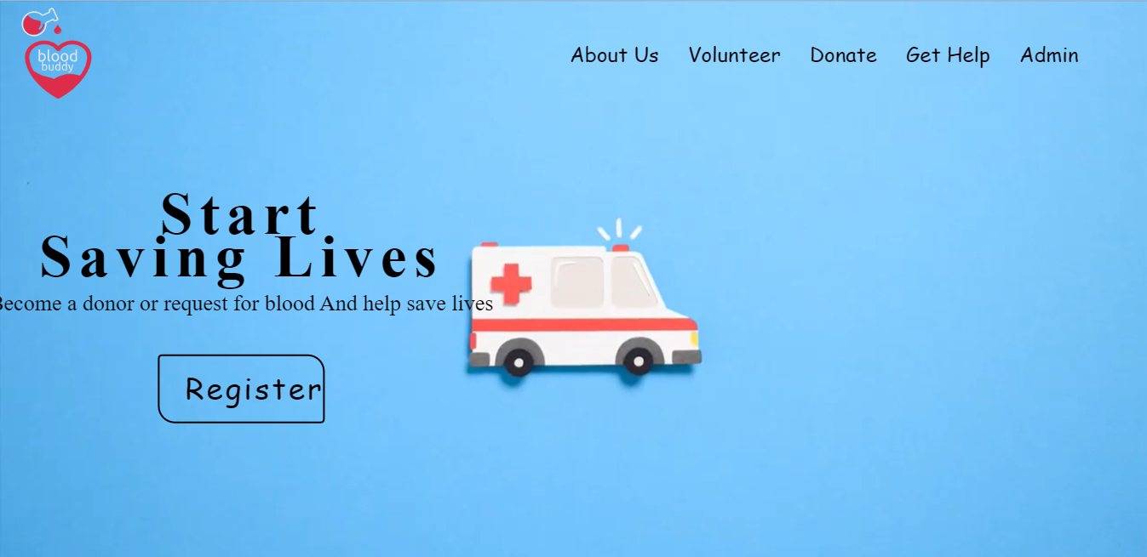

* DONATE :

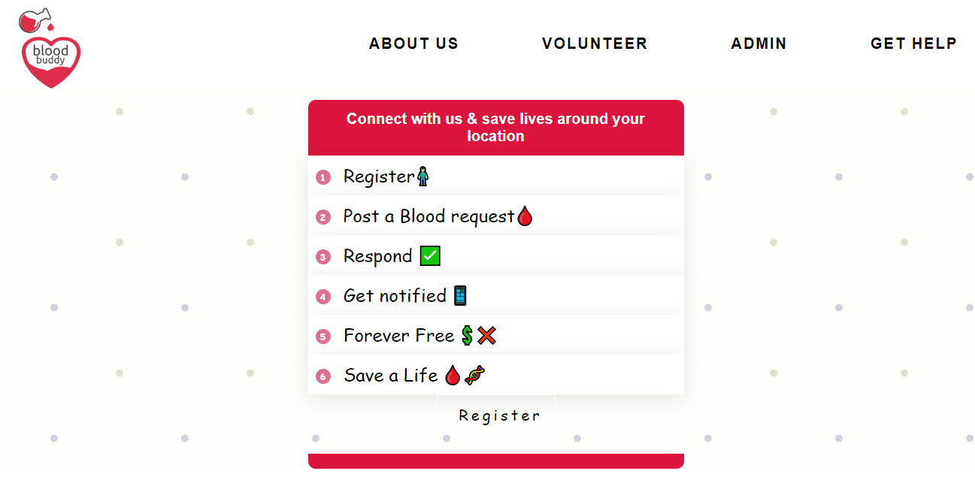

* **ABOUT US :**

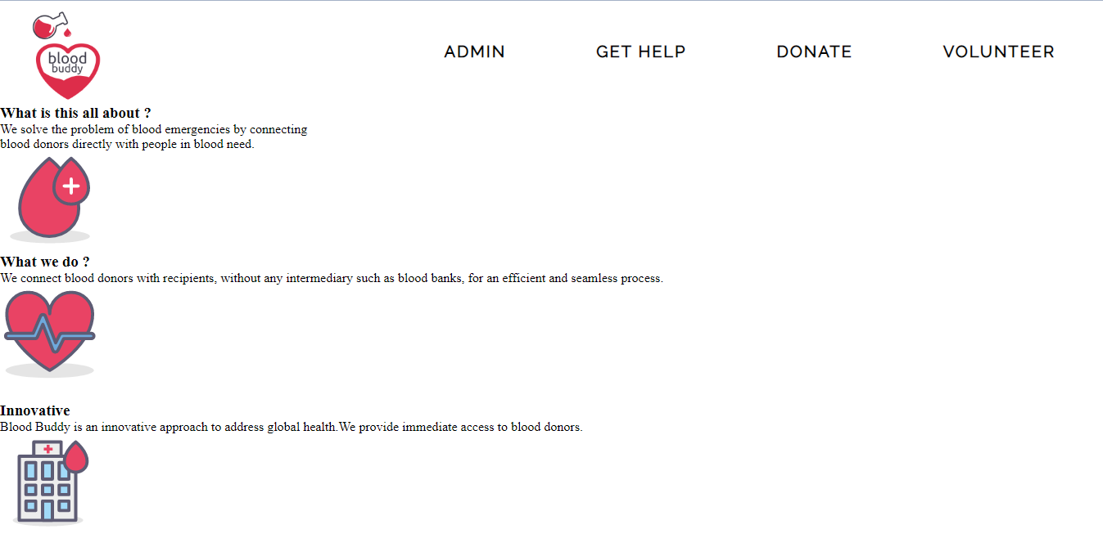

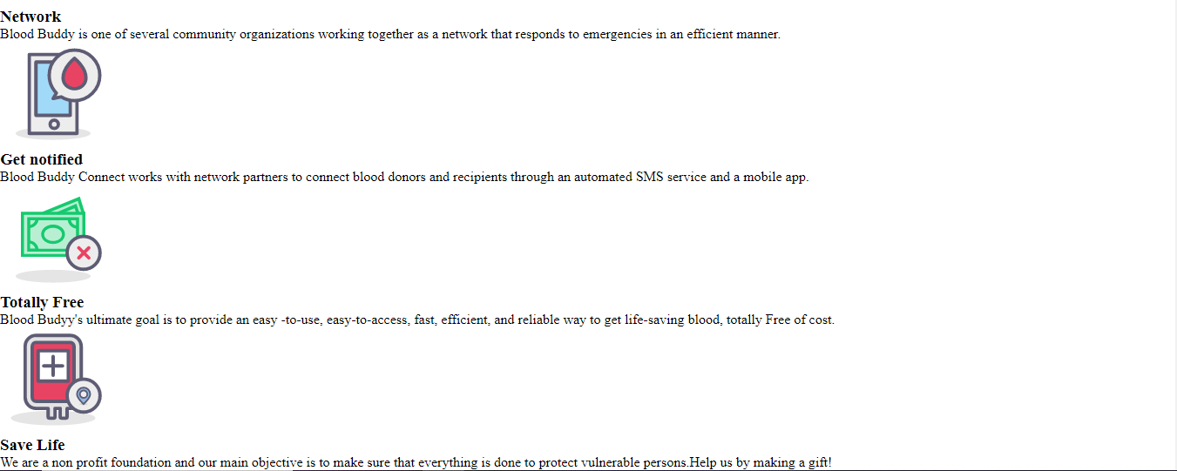

* GET HELP :

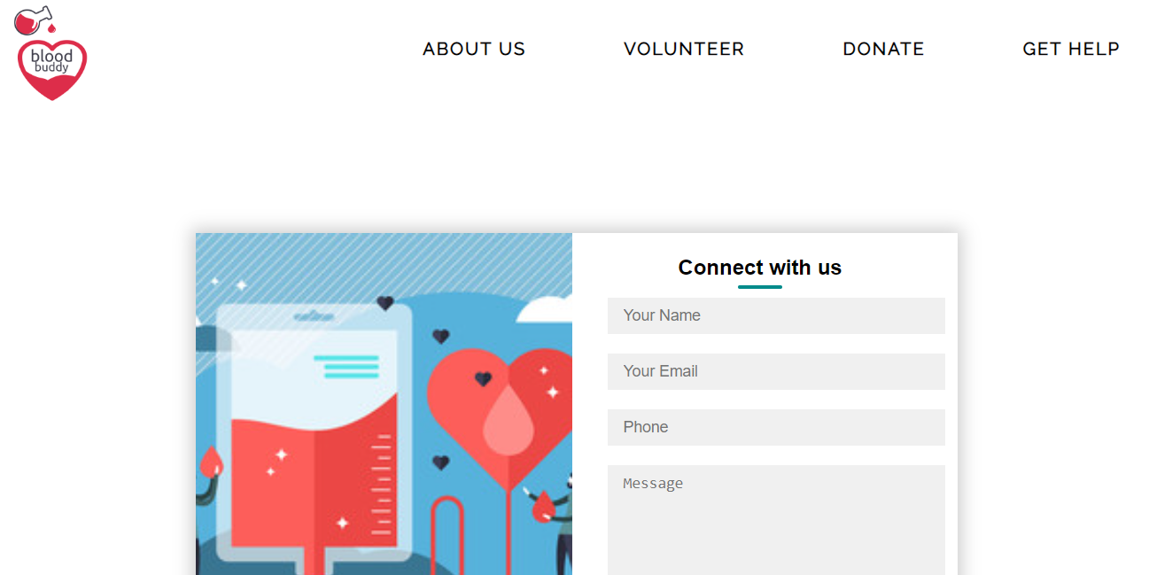

* VOLUNTEER :

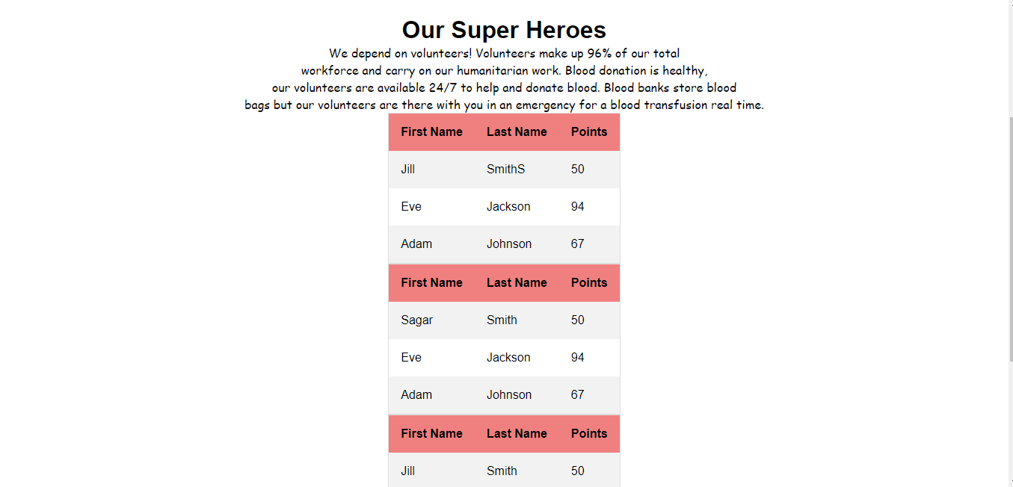



**CHAPTER:7**

**7.0 Testing:**

Testing is a group of techniques to determine the correctness of the application under the predefined script but, testing cannot find all the defect of application. The main intent of testing is to detect failures of the application so that failures can be discovered and corrected. It does not demonstrate that a product functions properly under all conditions but only that it is not working in some specific conditions.

Testing furnishes comparison that compares the behaviour and state of software against mechanisms because the problem can be recognized by the mechanism. The mechanism may include past versions of the same specified product, comparable products, and interfaces of expected purpose, relevant standards, or other criteria but not limited up to these.

Testing includes an examination of code and also the execution of code in various environments, conditions as well as all the examining aspects of the code.

**7.1 Levels of Testing:**

Software level testing can be majorly classified into 4 levels:

**1. Unit Testing:**

A level of the software testing process where individual units/components

of a software/system are tested. The purpose is to validate that each unit

of the software performs as designed.

**2. Integration Testing:**

A level of the software testing process where individual units are combined

and tested as a group. The purpose of this level of testing is to expose

faults in the interaction between integrated units .

**3. System Testing:**

A level of the software testing process where a complete, integrated

system/software is tested. The purpose of this test is to evaluate the

system's compliance with the specified requirements.

**4. Acceptance Testing:**

A level of the software testing process where a system is tested for

acceptability. The purpose of this test is to evaluate the system's

compliance with the business requirements and assess whether it is

acceptable for delivery.

**7.2 Types of Testing:**

**1. Manual Testing:**

The process of checking the functionality of an application as per the customer needs without taking any help of automation tools is known as manual testing. While performing the manual testing on any application, we do not need any specific knowledge of any testing tool, rather than have proper understanding of the product so we can easily prepare the test document.

Manual testing can be further divided into three types of testing, which are as follows: Manual testing can be further divided into three types of testing, which are as follows:

* White box testing
* Black box testing
* Gray box testing

**White-box testing:**

The white box testing is done by Developer, where they check every line of a code before giving it to the Test Engineer. Since the code is visible for the Developer during the testing, that's why it is also known as White box testing.

**Black box testing:**

The black box testing is done by the Test Engineer, where they can check the functionality of an application or the software according to the customer /client's needs. In this, the code is not visible while performing the testing; that's why it is known as black-box testing.

**Gray Box testing:**

Gray box testing is a combination of white box and Black box testing. It can be performed by a person who knew both coding and testing. And if the single person performs white box, as well as black-box testing for the application, is known as Gray box testing.

**2.Automation testing:**

Automation testing 0s a process of converting any manual test cases into the test scripts with the help of automation tools, or any programming language is known as automation testing. with the help of automation testing, we can enhance the speed of our test execution because here, we do not require any human efforts. We need to write a test script and execute those scripts.

**CHAPTER:8**

**8.0 Software Maintenance:**

* It is the process of changing, modifying, and updating software to keep up with customer needs.
* Software maintenance is done after the product has launched for several reasons including improving the software overall, correcting issues or bugs, to boost performance, and more. , Software maintenance is a natural part of SDLC (software development life cycle). Software developers don't have the luxury of launching a product and letting it run, they constantly need to be on the lookout to both correct and improve their software to remain competitive and relevant.
* Using the right software maintenance techniques and strategies is a critical part of keeping any software running for a long period of time and keeping customers and users happy.

**8.1 Categories of Software Maintenance:**

Maintenance can be divided into the following:

**1. Corrective maintenance:**

Corrective maintenance of a software product may be essential either to rectify some bugs observed while the system is in use, or to enhance the performance of the system.

**2. Adaptive maintenance:**

This includes modifications and updations when the customers need the product to run on new platforms, on new operating systems, or when they need the product to interface with new hardware and software.

**3. Perfective maintenance**:

A software product needs maintenance to support the new features that the users want or to change different types of functionalities of the system according to the customer demands.

**4. Preventive maintenance:**

This type of maintenance includes modifications and updations to prevent future problems of the software. lt goals to attend problems, which are not significant at this moment but may cause serious issues in future.

**8.2 Need for Maintenance:**

Software Maintenance must be performed in order to:

* Correct faults.
* Improve the design.
* Implement enhancements.
* Interface with other systems.
* Accommodate programs so that different hardware, software, system features, and telecommunications facilities can be used.
* Migrate legacy software.
* Retire software.

**CHAPTER:9**

**Conclusion:**

Our project is only a humble venture to satisfy the needs to manage their project work. Several user-friendly coding has also adopted. This package shall prove to be a powerful package in satisfy all requirements of the user. The objective of software planning is to provide a frame work that enable the manager to make reasonable estimate made within a limited time frame at the beginning of the software project and should be update regularly as the project regularly.

At the end it is concluded that we have made effort on following points.

* A description of background and context of the project and its relation to work already done in the area.
* Made statement of the aims and objectives of the project.
* The description of the purpose, scope and applicability.
* We define the project on which we are working in project.
* We describe the requirement specifications of the system and actions that can be done on these things.
* We designed user interface and security issues related to system.
* Finally, the system is implemented and tested according to the test cases.

**Future Plan:**

* To make the system fully automated.
* To make validation of the system for user friendly.
* To make the system more flexible for payment and other transaction.
* To develop mobile app for the system.

**Bibliography** :

* Visual Studio download:

https://code.visualstudio.com/download

* XAMPP download:

https://www.apachefriends.org/download.html

* PHP Concepts:

https://www.w3schools.com/php/php intro.asp

* HTML Concepts:

https://www.w3schools.com/html/html intro.asp

* CSS Concepts:

https://www.w3schools.com/css/css intro.asp

* JavaScript Concepts:

https://www.w3schools.com/javascript/javascript intro.asp